**1.1 INTRODUCTION**

In today’s fast-paced and increasingly competitive market, the bottom line of a firm’s marketing strategies and tactics is to make profits and contribute to the growth of the company. Customer satisfaction and service quality are global issues that affect all organizations, be it large or small, profit or non-profit, global or local. Many companies are interested in studying, evaluating and implementing marketing strategies that aim at improving customer satisfaction and maximizing share of customers in view of the beneficial effects on the financial performance for the firm. There has been a strong advocacy for the adoption of customer retention as one of the key performance indicators. service Quality and customer satisfaction have long been recognized as playing a crucial role for success and survival in today’s competitive market. Not surprisingly, considerable research has been conducted on these two concepts. Notably, the quality and satisfaction concepts have been linked to customer behavioural intentions like purchase and loyalty intention, willingness to spread positive word of mouth, referral, and complaint intention

Cloud telephony service providers are of paramount importance to both developed and emerging economies In India, they are projected to contribute greatly to the national goal of achieving status as a developed nation by the year 2021. There is stiff competition between various providers then customer satisfaction and service quality are a necessity for survival in the market. At the same time, Indians are becoming equipped with necessary knowledge about quality service delivery. Many telecommunication service providers in India offer various products and services in the market. They have to compete with each other to ensure optimal customer satisfaction in terms of products or service. Quality is generally regarded as being a key factor in the creation of worth and in influencing customer satisfaction. Hence, the telecommunication industry in India has to be strategically positioned to provide quality services to satisfy customers. To provide improved quality service, telecommunication companies need to investigate degree of customers’ sensitivity and expectations toward service quality. Armed with such information, telecommunication outfits are then able to strategically focus service quality objectives and procedures to fit the Indian market. The purpose of this study was to examine the service quality and customer satisfaction level of Bonvoice Solutions Pvt Ltd.

Customers are now more aware of the level of the service they get which has led the organization to give more attention to the level of the service they provide to their customers in order to be able to get more satisfaction which can lead to better loyalty from customers. Due to the exceptional rivalry and the antagonistic vibe of natural components, service quality has turned into a foundation advertising procedure for organizations. This features how vital enhancing service quality is to associations for their survival and development since it could enable them to handle these difficulties, they look in the aggressive markets. This implies benefit-based organizations are constrained to give astounding service to their clients with a specific end goal to have a reasonable upper hand. There is in any case, a requirement for these associations to comprehend what service quality is with a specific end goal to achieve their destinations. Service quality assurance is a fundamental construct for any business to become successful. Therefore, in this present decade, companies have gained better understanding of the importance of customer satisfaction especially in telecommunication sector and adopted it as a high priority operational goal. Customer satisfaction, a term frequently used in the business world, is a measure of how products and services supplied by a company meet or surpass customer expectation. Customer satisfaction is defined as "the number of customers, or percentage of total customers, whose reported experience with a firm, its products, or its services (ratings) exceeds specified satisfaction goals.”

Today the quality of products and services consumed is of great importance. It is widely accepted that surviving in difficult and competitive conditions of a market economy requires good quality production. To understand and asses the results of efforts realized for good quality production, quality should be measurable. While the quality of goods can easily be measured by taking into account the certain physical properties, the measurement for services is rather difficult because the quality in this case depends on large number of factors.

Customer satisfaction is the response of consumers to the conformity of evaluations that are felt in previous expectations. In order to be able to win the competition, companies are required to always maintain customer trust and satisfaction by improving the quality of service so that customer satisfaction increases. Companies need to carefully determine consumer needs, as an effort to meet expectations and increase customer satisfaction for the services provided. The creation of quality services will certainly create satisfaction with service users. The quality of service itself must begin with the customer's needs and end in the customer's perception or assessment. Now the word satisfaction is widely used among customers as well as consumers to describe the satisfaction of their needs and value creation. In various definitions of satisfaction, it specifies that this is indispensable factor that firms wants to obtain from consumers for survival in market. The satisfaction idea as long as for a long time produce the particular source that connected with marketing ideas. To explain variations inside satisfaction, the number of antecedents that usually evaluated such as price label quality, service and its expectation. With the passage of time, customer satisfaction landscapes attaining more attention as compared to previous. Beside analysis associated with customer satisfaction and also its specific determinants, these practices are focused on customer satisfaction related results

Service quality is an important source of competitive advantage in telecommunication sector. Service quality is used to differentiate and add value to service offerings and as a way to win strategic competitive advantage. New managerial methods explain quality as the customer satisfaction, for that reason all the organizations have to recognize the high quality and quick service offering obstacles and solve them. Customer satisfaction and Service quality are important concepts to telecommunication companies to earn customer loyalty. Telecommunication industries are paying greater attention to customer satisfaction and service quality, for reasons such as increased deregulation and competition. Satisfaction from service quality is frequently evaluated in terms of functional quality and technical quality. Regularly, customers do not have lot information about the technical phases of a service; therefore, functional quality becomes the main aspect from which to form perceptions of quality of service. Service quality may be described as customer perception of how well a service assembles or go over’s their expectations. Providing excellent customer satisfaction and high service quality is the significant matter and challenge meeting the current service industry. Customer satisfaction and service quality have been important topic both for the researches in the field of marketing and for the academic world.

**1.2 STATEMENT OF THE PROBLEM**

Service quality and consumer satisfaction are essential ideas that telecom sector must comprehend so as to stay focused in business and thus develop it. It is vital for organizations to know how to gauge these builds from the buyers' point of view with a specific end goal to better comprehend their requirements and consequently fulfil them. Service quality is viewed as imperative since it prompts higher consumer loyalty, benefit, less cost, client devotion and maintenance. According to Chingang and Lukong (2010) service quality was defined as "the overall assessment of a service by the customers". Based on that, the level of the service is determined by customers is seen very important by the organization to determine the ability of the organization to deliver such service and to satisfy customers leading to their satisfaction. In this survey determines the level of customer satisfaction and service quality. It will help improve on its deficiencies relating to dimensions of service quality and customer satisfaction, thereby satisfying customers leading to loyalty and high business volumes which are a good sign for high business performance and improved competitiveness

* 1. **OBJECTIVES**
* To analyse the service quality of Bonvoice Solutions Pvt Ltd.
* To find out the customer satisfaction level of Bonvoice Solutions Pvt Ltd.

**1.4 SIGNIFICANCE OF THE STUDY**

Telecom industry is one of the growing and well-established industries in case of service and competition also. Since there is high competition between the brands, it is important to retain customers in the long run. This study contributes the knowledge on service quality and customer satisfaction level, it includes various dimensions of service quality and customer satisfaction in bonvoice solutions.

The study finding also be relevant input to the management of company to identifying the existing strength and weaknesses of service quality delivery and level of customer satisfaction experienced by customers during period of usage. In addition, this study will help improve on its deficiencies relating to dimensions of service quality and customer satisfaction.

**1.5 LIMITATION OF STUDY**

This paper is aimed to study the impact of service quality on customer satisfaction. The limitation of the study was that the access to data was restricted to some extent. Being a student, it was not easy to access a wider area of respondents. There are numerous other variables that influence the service quality and customer satisfaction can’t be taken for study which are the emotional intelligence, employee motivation and impact of brand image on customer satisfaction.

**1.6 SCOPE OF STUDY**

The findings of this study will be helpful for Bonvoice Solutions Pvt Ltd to shape their service quality and improving customer satisfaction and retaining customers to gain a higher market share and sustainable growth in telecom industry in India. Secondly, upcoming researchers have more opportunity to carry out their research in improved situations.

**1.8 INDUSTRY PROFILE**

Currently, India is the world’s second-largest telecommunications market with a subscriber base of 1.16 billion and has registered strong growth in the last decade. The Indian mobile economy is growing rapidly and will contribute substantially to India’s Gross Domestic Product (GDP) according to a report prepared by GSM Association (GSMA) in collaboration with Boston Consulting Group (BCG). In 2019, India surpassed the US to become the second largest market in terms of number of app downloads.

The liberal and reformist policies of the Government of India have been instrumental along with strong consumer demand in the rapid growth in the Indian telecom sector. The Government has enabled easy market access to telecom equipment and a fair and proactive regulatory framework, that has ensured availability of telecom services to consumer at affordable prices. The deregulation of Foreign Direct Investment (FDI) norms has made the sector one of the fastest growing and the top five employment opportunity generator in the country.

**Market Size**

India is the world’s second-largest telecommunications market. The total subscriber base, wireless subscriptions as well as wired broadband subscriptions have grown consistently. Tele-density stood at 84.88%, as of April 2022, total broadband subscriptions grew to 788.77 million until April 2022 and total subscriber base stood at 1.16 billion in April 2022.

Gross revenue of the telecom sector stood at Rs. 64,801 crore (US$ 8.74 billion) in the first quarter of FY22.

The total wireless data usage in India grew 16.54% quarterly to reach 32,397 PB in the first quarter of FY22. The contribution of 3G and 4G data usage to the total volume of wireless data usage was 1.78% and 97.74%, respectively, in the third quarter of FY21. Share of 2G data usage stood at 0.48% in the same quarter.

Over the next five years, rise in mobile-phone penetration and decline in data costs will add 500 million new internet users in India, creating opportunities for new businesses. By 2025, India will need ~22 million skilled workers in 5G-centric technologies such as Internet of Things (IoT), Artificial Intelligence (AI), robotics and cloud computing.

**Investment /Major Development**

With daily increasing subscriber base, there have been a lot of investment and development in the sector. FDI inflow in the telecom sector stood at US$ 38.33 billion between April 2000-March 2022.

Some of the developments in the recent past are:

* In January 2022, Google made a US$ 1 billion investment in Airtel through the India Digitization Fund.
* In October 2021, Vodafone Idea stated that it is in advanced talks to sell a minority stake to global private equity investors including Apollo Global Management and Carlyle to raise up to Rs. 7,540 crore (US$ 1 billion) over the next 2-3 months.
* In October 2021, British satellite operator Inmarsat Holdings Ltd. announced that it is the first foreign operator to get India’s approval to sell high-speed broadband to planes and shipping vessels. Inmarsat will access the market via Bharat Sanchar Nigam Ltd. (BSNL) after BSNL received a license from the Department of Telecommunications. In October 2021, Dixon Technologies announced plans to invest Rs. 200 crore (US$ 26.69 million) under the telecom PLI scheme; this investment will include the acquisition cost of Bharti Group’s manufacturing unit.
* In September 2021, Bharti Airtel announced an investment of Rs. 50 billion (US$ 673 million) in expanding its data centre business to meet the customer demand in and around India.
* In August 2021, Tata Group company Nelco announced that the company is in talks with Canadian firm Telesat to sign a commercial pact for launching fast satellite broadband services in India under the latter’s Lightspeed brand, a move which will pit the combined entity against Bharti Enterprises-backed OneWeb, Elon Musk’s SpaceX and Amazon.
* In March 2021, Vodafone Idea Ltd. (VIL) announced that the acquired spectrum in five circles would help improve 4G coverage and bandwidth, allowing it to offer ‘superior digital experience’ to customers.
* In March 2021, Advanced Television Systems Committee (ATSC) and Telecommunications Standards Development Society, India (TSDSI) signed a deal to boost adoption of ATSC standards in India in order to make broadcast services available on mobile devices. This allows the TSDSI to follow ATSC standards, fostering global digital broadcasting standard harmonisation.
* In the first quarter of FY21, customer spending on telecom services increased 16.6% y-o-y, with over three-fourths spent on data services. This spike in consumer spending came despite of the COVID-19 disruption and lack of access of offline recharges for a few weeks
* India had over 500 million active internet users (accessed Internet in the last one month) as of May 2020.

**Government Initiatives**

The Government has fast-tracked reforms in the telecom sector and continues to be proactive in providing room for growth for telecom companies. Some of the key initiatives taken by the Government are as follows:

* In Union Budget 2022-23 the Department of Telecommunications was allocated Rs. 84,587 crore (US$ 11.11 billion) out of which Rs. 30,436 crore (US$ 3.99 billion) was revenue expenditure which was 36% of the total expenditure and Rs. 54,150 crore (US$ 7.11 billion) was capital expenditure which is 64.01% of total expenditure.
* To drive the development of 6G technology, the Department of Telecommunications (DoT) has developed a sixth generation (6G) innovation group.
* In October 2021, Telecom Secretary Mr. K. Rajaraman inaugurated the Quantum Communication Lab at the Centre for Development of Telematics (C-DOT), Delhi, and unveiled the indigenously developed Quantum Key Distribution (QKD) solution by C-DOT. QKD can support a distance of >100 kms on standard optical fibre.
* In August 2021, the Department of Telecommunications (DoT) initiated discussions with banks to address financial stress in the telecom sector, particularly Vodafone Idea Ltd. (VIL) that urgently requires fund infusion to stay afloat.
* In August 2021, the Department of Telecommunications (DoT) officials stated that it is working on a package, which includes reducing the revenue share licence fee to 6% of adjusted gross revenue (AGR) of the operators from the current 8%. This would be done by reducing the 5% universal service obligation levy by two percentage points and providing relief of about Rs. 3,000 crore (US$ 403.63 million) annually to the operators.
* In July 2021, Bharat Broadband Network Limited (BBNL), on behalf of the Department of Telecommunication, invited global tender for the development of Bharat Net through the Public-private Partnership model in 9 separate packages across 16 states for a concession period of 30 years. Under this project, the government will provide a maximum grant of Rs. 19,041 crore (US$ 2.56 billion) as viability gap funding.
* The Rs. 12,195 crore (US$ 1.65 billion) production-linked incentive (PLI) scheme or telecom is expected to bring in investment of around Rs. 3,000 crore (US$ 400.08 million) and generate huge direct and indirect employment.
* In April 2021, the government pointed out that firms such as Ericsson and Nokia are now eager to expand their operations in India, and global companies like Samsung, Cisco, Cena and Foxconn have expressed interest to set up their manufacturing base in the country for telecom and networking products.
* In March 2021, TEPC (Telecom Equipment Export Promotion Council) organized India Telecom 2021—a platform for convergence of technologies and business exchange.
* The Union Cabinet approved Rs. 12,195 crore (US$ 1.65 billion) production-linked incentive (PLI) scheme for telecom & networking products under the Department of Telecom.
* In 2021-22, the Department of Telecommunications has been allocated Rs. 58,737.00 crore (US$ 8 billion). 56% allocation is towards revenue expenditure and the remaining 44% is towards capital expenditure.
* Under Union Budget 2021-22, the government allocated Rs. 14,200 crore (US$ 1.9 billion) for telecom infrastructure that entails completion of optical fibre cable-based network for Defense services, rolling out broadband in 2.2 lakh panchayats and improving mobile services in the North East.
* On January 15, 2021, India and Japan signed an MoU to enhance cooperation in the field of Information and Communications Technologies. The MoU was signed between the union minister for Communications, Electronics and IT, Ravi Shankar Prasad, and the Japanese Minister for Internal Affairs and Communications, Takeda Ryota.
* On January 6, 2021, the Department of Telecommunications (DoT) issued Notice Inviting Applications (NIA) for auction of Spectrum in 700 MHz, 800 MHz, 900 MHz, 1,800 MHz, 2,100 MHz, 2,300 MHz and 2,500 MHz bands. Last date for submission of applications for participation in the auction is February 5, 2021, and auction to commence online from March 1, 2021.
* In December 2020, the Union Cabinet, chaired by the Prime Minister, Mr. Narendra Modi, approved a proposal by Department of Telecommunications for setting up of Public Wi-Fi Networks by Public Data Office Aggregators (PDOAs) to provide public Wi-Fi services through Public Data Offices (PDOs).
* In December 2020, the Union Cabinet, chaired by the Prime Minister, Mr. Narendra Modi, approved the provision of submarine optical fiber cable connectivity between Mainland (Kochi) and Lakshadweep Islands (KLI Project).
* On November 4, 2020, The Union Cabinet, chaired by the Prime Minister, Mr. Narendra Modi, approved to sign a Memorandum of Understanding (MoU) between the Ministry of Communication and Information Technology and the Department of Digital, Culture, Media and Sports (DCMS) of United Kingdom Government on cooperation in the field of telecommunications/information and communication technologies (ICTs).
* On September 21, 2020, Prime Minister, Mr. Narendra Modi launched a project to connect all 45,945 villages in Bihar with optical fiber internet service. This project will be completed by March 31, 2021 at a cost of Rs. ~1,000 crore (US$ 135.97 million); Rs. 640 crore (US$ 87.01 million) of capital expenditure will be funded by Department of Telecommunications.
* In March 2020, the government approved the Production Incentive Scheme (PLI) for Large- scale Electronics Manufacturing. The scheme proposes production-linked incentive to boost domestic manufacturing and attract large investments in mobile phone manufacturing and specified electronic components including Assembly, Testing, Marking and Packaging (ATMP) units.
* FDI cap in the telecom sector has been increased to 100% from 74%; out of 100%. In October 2021, the government notified 100% foreign direct investment (FDI) via the automatic route from previous 49% in the telecommunications sector. FDI of up to 100% is permitted for infrastructure providers offering dark fiber, electronic mail and voice mail.

**Achievements**

Following are the achievements of the Government in the past four years:

* Department of Telecommunication launched ‘Tarang Sanchar’ - a web portal sharing information on mobile towers and EMF Emission Compliances.
* Payments on unified payments interface (UPI) hit an all-time high of 3.65 billion (by volume), with transactions worth ~Rs. 6.54 trillion (US$ 87.11 billion) in September 2021.
* Over 75% increase in internet coverage—from 251 million users to 446 million

**Road Ahead**

Revenue from the telecom equipment sector is expected to grow to US$ 26.38 billion by 2020. The number of internet subscribers in the country is expected to double by 2021 to 829 million and overall IP traffic is expected to grow four-fold at a CAGR of 30% by 2021.

According to a Zenith Media survey, India is expected to become the fastest-growing telecom advertisement market, with an annual growth rate of 11% between 2020 and 2023.

The Indian Government is planning to develop 100 smart city projects, and IoT will play a vital role in developing these cities. The National Digital Communications Policy 2018 envisaged attracting investment worth US$ 100 billion in the telecommunications sector by 2022. App downloads in India is expected to increase to 18.11 billion in 2018F and 37.21 billion in 2022F.

Note: Conversion rate used in July 2022, Rs 1 = US$ 0.013

**Advantage of Indian telecommunication**

**Robust demand**

* In India, the total subscriber base stood at 1178.41 million in December 2021.
* Tele-density of rural subscribers reached 44.40% in December 2021. From around 4,200 petabytes in 2018, India's overall wireless internet data usage has increased by almost 7x to 32,397 petabytes in 2021.
* Also, India is one of the biggest consumer of data worldwide. As per TRAI, average wireless data usage per wireless data subscriber was 11 GB per month in FY20.

**Attractive Opportunities**

* India’s 5G subscriptions to have 350 million by 2026. accounting for 27% of all mobile subscriptions.
* For domestic consumption and export, Ericsson will start manufacturing 5G radio products in India.
* By 2025, India will need ~22 million skilled workers in 5G-centric technologies such as Internet of Things (IoT), Artificial Intelligence (AI), robotics and cloud computing

**Policy Support**

he Union Cabinet approved Rs. 12,195 crore (US$ 1.65 billion) production-linked incentive (PLI) scheme for telecom & networking products under the Department of Telecom. On October 14, 2021, 31 companies comprising 16 MSMEs and 15 Non-MSMEs (eight domestic and seven global companies) have been approved under the Production-linked Incentive (PLI) Scheme. To drive the development of 6G technology, the Department of Telecommunications (DoT) has developed a sixth generation (6G) innovation group.

**Increasing Investment**

* In Union Budget 2022-23 the Department of Telecommunications was allocated Rs. 84,587 crore (US$ 11.11 billion). Revenue expenditure was allocated 36% and capital expenditure 64%.
* FDI inflow in the telecom sector stood at US$ 38.25 billion between April 2000-December 2021

**1.9 COMPANY PROFILE**

Bonvoice Solutions Pvt Ltd is specialize in Communication solutions and consultation for IoT manufacturing companies. company provides communications solutions for all types of Businesses. Bonvoice‘s mission is to help your business to meet its full potential by optimizing customers’ internal and external communications. Bonvoice team is excited and spirited about the potential of Cloud PBX technology and how it could revolutionize communications with businesses in the near future. bonvoice also provides eSIM for IOT device manufacturing companies.

Bonvoice focus on easing the communication with customers and enterprises. Company’s solution will help client to interact with their customers with utmost ease. IVR and Dialer manage all the calls in and out from the system. bonvoice encourage the work from home scenarios and distributed customer care management. Agents can easily communicate with customers and vice versa with complete call tracking including call time, call duration and call recording with details of the caller irrespective of the location. Company’s customized 'click to call' solution enables the client to connect with their customers without any manual dial from the customer. It is quite easy to integrate with your website, Digital marketing and other marketing mediums.

Bonvoice are in an innovative way to become the part of new generation communication solutions. Company will continue efforts to ensure the smooth and productive communication with customers. The next significant move will be the evolution of EPBX to cloud PBX. Company will help each and every Enterprises right from Small scale to Large scale organizations to create and maintain a good rapport with their valuable customers

CIN - U72900KL2018PTC052353

Company Name - BONVOICE SOLUTIONS PRIVATE LIMITED

Company Status - Active

Roc -Ernakulam

Registration Number -52353

Company Category - Company limited by Shares

Company Sub Category- Non-govt company

Type: Private

Industry: Telecommunication

Founded: 10 March 2018

Headquarters: Bonvoice Solutions Private Limited, 3rd Floor, 10K building Kerala Technology Innovation Zone Kinfra Hi-tech Park, Kalamassery Cochin-683503

Key people: FEROZ MUJEEB REHMAN (Director), GIS GEORGE (Director) AJITH JOSEPH (Additional Director)

Products: IVR, Smart Dialler, Mcs, Bulk SMS, Click To Call Etc

Total subscriber: 400+

Website: http://www.bonvoice .com

**PRODUCTS**

eSIM

Developed by the GSMA and already widely accepted by the telecoms market, eSIM is the new standard in SIM card technology. A rewritable chip, built directly onto the device, the eSIM brings wide ranging benefits to consumers, enterprises and IoT solutions.

* Swap profiles without removing the SIM. Store multiple profiles on a single device.
* Flexibility of SIM types accounts for every possible use case and often takes up much less space than traditional SIMs.
* Roaming and moving devices can now automatically navigate between network providers.
* Enable IoT deployments to get updated by pushing profile changes to the devices from a unified control platform.
* Improve service quality

Swap between carriers to avoid quality & signaling issues, for example in rural areas and near country borders. Roaming and moving devices can automatically navigate between carrier networks.

* Forget about swapping physical SIMs

Get one eSIM for coverage and swap carriers over-the-air, without replacing SIM cards ever again.

* Freedom and Security at the best price
* No more locked in situations.
* eSIM provides you the freedom to change

**Cloud PBX**

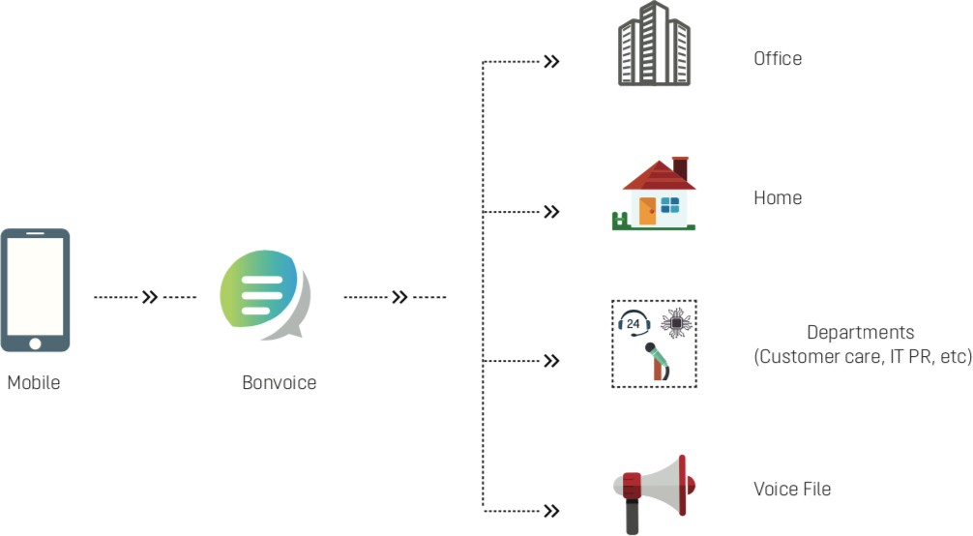Cloud PBX is a sophisticated, fully-automated telephone system that handles your incoming calls, routing them to voicemail or a number of your choosing and provides host has a host of

other benefits, including

* Live Answering
* Answers incoming calls with your company name
* Works out cheaper than hiring a full-time receptionist or personal assistant
* Forwards all your call details by Email or SMS
* Provides multi-level IVR
* Increases the mobility and flexibility of your staff without missing callsRoutes calls to any desired number using a virtual number subscriptions on the go. If you are facing negative price changes or get better prices elsewhere, simply download the carrier that best fits your needs.

**Virtual Number**

A virtual phone number is a standard telephone number that is not locked down to a specific phone. This allows you to route a voice call to any phone or workflow.

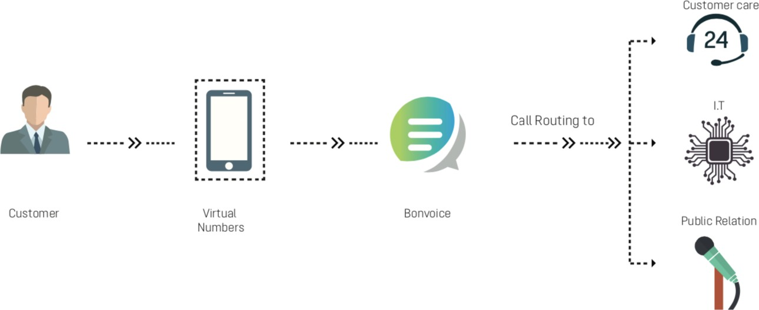

* Safeguards customer identity • Prevents misuse of sensitive
* information Connects two parties
* without revealing their phone number

**Missed Call Solution**

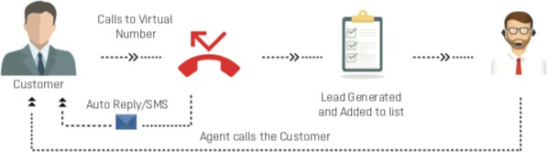Our cutting-edge correspondence strategy empowers you to effortlessly draw in with your clients

* Identifies hot leads using missed calls
* Sends automated SMS Reply
* Customizes the reply for each called

**Voice Broadcast**

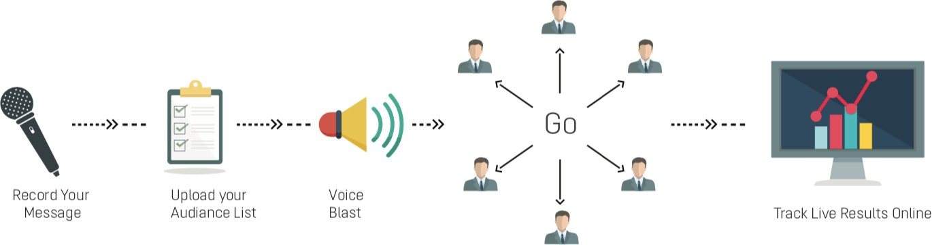A ringing phone is hard to ignore, so we use voice call to reach your customers about new events or new offers increases the likelihood of engagement.

* Expands your business presence
* Reaches more customers on a single click
* Schedules campaign messages
* Quickly uploads a contact list into our portal and get started with your campaign
* Makes Your Voice More Powerful

**Smart Dialer**

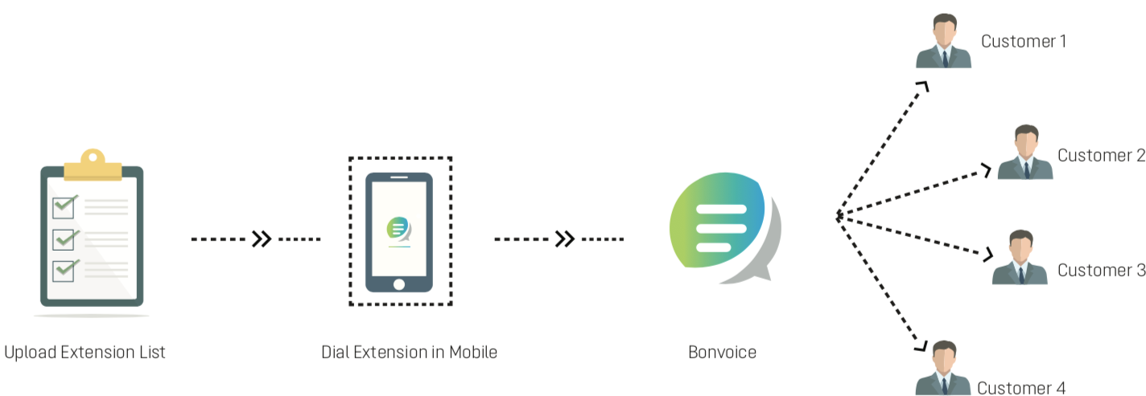Securing your hot leads by masking it with extensions and connecting to a large number of mobiles.

* Uploads a contact list to connect n number of extensions
* The phone number will be masked to the caller
* Leads kept secure with the client
* Will be able to connect to hot leads by entering a virtual number

**Click to Call**

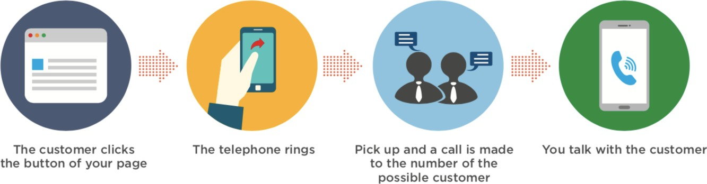An immediate calling tool provided on your website/App connects you with your customers.

* Press the given button to initiate the call to desired number
* Use this facility in websites and app to connect your customers directly to your sales team
* No customer calls will be missed

**Residence Connect**

Connects all in your apartment or residential area without providing or knowing personal phone numbers.

* Masks phone number
* Connects all rooms with extensions
* No hardware cost
* Connects even if you are not at home
* Releases you from the responsibility of giving phone numbers to anyone within the apartment



**School Connect**

Connects your school authorities with students/parents by an app.

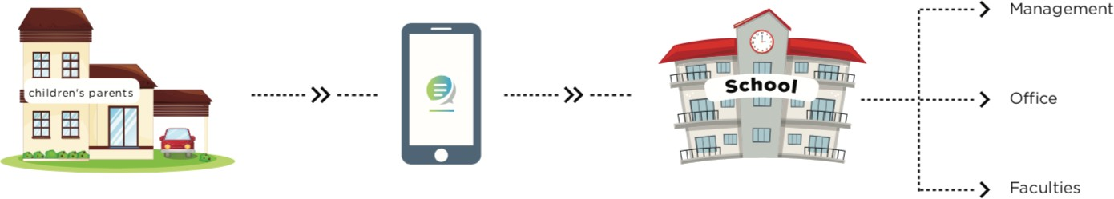

* Faculties’ mobile numbers will be hidden from callers
* Faculty will be easily selected by parents/students by using filters in the App
* Extensions will be provided to each faculty

**COMPETITORS**

**1. KNOWLARITY -** From launching Cloud Telephony at the initial stage to Artificial Intelligence-powered Speech Analytics, and Video Communication Platform – they have come a long way. The ingenious solutions are leveraged by the most innovative companies to collaborate, communicate, and improve ROI by gaining strategic insights for improved business decisions to stay ahead of the curve.

Trusted by over 6000+ businesses across 65+ countries, we help businesses across every industry realize the full potential of cloud-based communication. With over 300+ employees, we offer businesses unparalleled reliability and intelligence by enabling business communication through voice, video and AI-enabled Chat Bots/Voice Bots.

**Products**

* **Cloud Contact Centre** - Ensure a seamless customer experience with minimal investment to streamline complex business communication on a robust Cloud-Based Contact Centre Solution. With an easy to integrate cloud platform, gain deeper valuable insights into everyday customer conversations.
* **Virtual Number** - A Virtual Number is a cloud-based number used for routing incoming customer calls to the preferred agents as per customer queries. Businesses can use local and international virtual business numbers to expand their market reach.
* **IVR Solution** - Interactive Voice Response (IVR) is a technology that lets businesses automate customer interactions in both inbound and outbound calls via pre-recorded voice messages & Text to Speech technology. It works on DTMF input entered by the customer. With IVR, interact with callers & route calls to agents when required
* **Number Masking** - Number Masking is an advanced data protection measure established to ensure the privacy of the agent and the caller’s personal details. Facilitate a seamless connection of two on-call entities without the disclosure of phone numbers. Record and monitor the calls for enhanced performance of the agents with real-time insights. Use Analytics dashboard for understanding customers' needs and ensuring proper training for agents
* **Lead Management** - The Tentacle lead management software enables businesses to automate the lead generation process to capture customer inputs and nurture potential prospects to strengthen the entire sales process. Followed by which customer service support agents or tele callers can contact customers anytime anywhere.
* **Missed Call** - A missed call solution aids businesses to call back their customers who gave missed calls on their business numbers. The call is processed via auto-dialer, connecting the target audience with either an automated IVR message, a voice bot or a live agent
* **Toll Free Number** - customers can reach out to you for free on your 1800 business toll free number. Ensure seamless interaction between the agents and customers for query resolution, upcoming promotions or events
* **Automated Outbound Calling** - An automated calling solution is a process that enables recorded voice interaction with the caller without human intervention. It enables businesses to place concurrent automated outbound call blasts to their target customers
* **Click to Call** - The click-to-call solution is a real-time-based calling widget that can be configured on a website/mobile app for customers to reach a business to get connected instantly. It aids businesses to allow their customers to reach their sales and support just by submitting their contact number to get a call back within seconds
* **Softphone with WebRTC & MPLS** - WebRTC (Web Real-time Communications) is an open-source standard, that businesses can embed into web-based applications with the same contact canter features for inbound/outbound calls. More suitable for the remote workforce as it works on laptop/desktop/mobile devices. MPLS (Multi-Protocol Label Switching) aids businesses in switching from on-premise to cloud for inbound/outbound voice calls via internet with the same contact center features. It works without the use of mobile/fixed telephone lines to offer high-quality (HD) audio communication improving workforce productivity.
* **True caller** - A True caller Verified Business Caller ID experience aids businesses to manifest themselves as a verified caller by letting their users know who is calling them via brand name, logo, verified badge & industry tags. This ensures a process of building brand trust among your customers to bridge the gap between a genuine and fraudulent caller for improved customer service with better response rates
* **Auto Dialer** - An Auto Dialer is a software which helps boost agents’ productivity by dialing calls automatically and once connected, either a pre-recorded message plays or the call is directly transferred to a live agent. Knowlarity offers Progressive and Predictive Dialers as part of the Outbound Call Center to enable users to improve their agent productivity for efficient operations. In Progressive Dialers, the system automatically dials the next number on the list. This removes the wait time between calls and can improve productivity significantly. In Predictive Dialers, a new set of customers are dialed out according to available agents in the queue

**Features**

* **Easy Integration-** Integrate the voice solutions into your existing CRMs and run your business as usual
* **Collate and Analyse Every Data –**Collate and analyse all your customer data in real-time on a single platform and keep it ready with a single click
* **Offer Explicit Customer Experience** - Introduce simple communication ways to your customers to let them reach you through their preferred channel of engagement
* **Be Available Anytime Anywhere** - Connect with your customers from any region at any time-zone
* **Scalable** - Expand your business at ease on a smart technology platform without any limitations
* **Reliable** -Enabling enterprise-grade security and highest up-time reliability for **businesses**

**2. VOXBAY SOLUTIONS-** have been globally leading the telecom infrastructure industry ever since its inception. They have transfigured the very face of Enterprise Communications and have been quite a forerunner in cloud telephony-oriented communication solutions. After adequate research, Voxbay has developed this call management solution suitable for all the different types of business enterprises.

**Products**

1. Smart Voice
2. Call Centre Solution
3. Social Media Integration

**Features**

* **Multi-Level IVR-** Multi-level Interactive Voice Response is a customized automated response to greet the callers to address their queries. When a call is received from an external source, it guides them through a series of instructions via its self-help features. Its flexibility allows it to modify as per the business demands. Voxbay is the best IVR provider in India.
* Customized Automated response
* Guides the Caller
* Flexible
* **Call Recording & Monitoring-**This feature helps to record and save calls for the admin’s future reference. Stay updated with every ongoing call between the customer and team with the help of the remote admin panel. It also allows monitoring of the calls within the organization to improve the quality of services.
* Records and Stores call data
* Monitors calls
* Helps improve micro management
* **Live Call Monitoring (Call Barging)-**Call Barging is a unique feature which allows stepping in on live calls. There are three modes in Call Barging which can be used according to the purpose. 3 modes of call barging are as follows:
* Listen
* Whisper
* Conference
* **Live Call Transfer & Conference-** Call transfer is a contact centre function that allows the transfer of live calls to another agent. It’s a telephony feature that allows the customer facing employees to quickly transfer an incoming call smoothly to any desired user extension.
* Transfers live calls (Blind or Attended)
* Calls are transferred smoothly and quickly
* Transfer live calls to any desired user extension
* Contact centre functionality
* **Time Based Routing**-Time based routing manages your calls even after office hours. This helps the caller to reach the right and available person without any loss of time.
* Constant call handling
* Ensures client satisfaction
* Extensive availability of support
* **Call Masking-**Call masking is one of the prominent features which protects customer data. It enables enterprises to keep conversation directly between the service provider and the customer. It prevents siphoning/tapping of any sensitive information regarding the customer, which keeps privacy in check. This blocks any possibility for foul play.
* Safeguard’s customer data
* Virtual number for each customer
* Tends to privacy requirements
* **Virtual Number -** Virtual number or access number is a telephone number which isn’t linked to a single fixed location. It does not require a sim card or a physical address. It utilizes secure PSTN to place real telephone calls between people. These numbers can be used to make as well as receive calls. Each customer is assigned a virtual number which is unique to them.
* Unique Virtual and access number
* Not linked to a specific location
* No need of SIM or physical address
* Uses safe PSTN to place real time calls
* **Agent Login & Performance Reports -**The admin dashboard gives complete access to one’s performance and login details. It can be accessed by the agent to login and to anytime monitor how they have been performing. This consequently increases productivity as the regular performance report is right in front. It aids agents to login easily and keeps a track of their performance reports.
* Access to login and performance
* Managers can keep track of team performance
* Immediate improvements within departments
* **Voice Mail-** Voice mail is a digitally recorded spoken message. It effortlessly records the voice note and gets stored in the digital mailbox of the retriever. They can later listen to it and respond.
* Leave a voice message if you are unavailable for calls.
* Customize your greetings
* Automatically saves your note in the retriever’s mailbox
* **World Class Products-**Voxbay stands out in what it does, not just by the virtue of our quality but also as the products and services offer invariable credibility.
* **Quality Services-** A classic policy is followed when it comes to our products. Voxbay has been ranked the best call management solution in India. Quality of services is never compromised for. Voxbay never settles for anything less than the best while providing services to the businesses. Managers can keep track of team performence
* **Free Demo**- If a trial is required, before availing our services, we do provide a free demo session for your convenience.
* **24X7 Support-**Always ready with 24 x7 support to serve your business better. We have a highly proficient support team working even beyond office hours to ensure 100% customer satisfaction.

**3. MY OPERATOR -** My Operator was started with a vision to help businesses utilise cloud telephony to improve their customer call handling as well as customer communication. With a team of five in 2013, we have now become a family of 180+, and the growth continues. Company created this product with the belief that each customer call is a potential business opportunity. Our product helps businesses manage and optimize each customer call and enhance their customer calling experience. Today, companies all over the world are realizing the benefits and power of cloud communication. With our product, we want to expand both its knowledge and usage to businesses across the globe. Company is a team of creative and experienced people working towards improving on-call customer communication for businesses of all sizes and industries.

**Products**

1. Office IVR system
2. Cloud call centre
3. Missed call solution
4. Helpline number
5. Bulk SMS
6. Call masking solution

**Features**

* **Call recording**- Analyse your customer conversations to understand the requirements of your callers.
* **Call tracking**- Track and monitor all your business calls to ensure you do not miss any potential leads.
* **Push reports**-Get detailed analytical reports of your business calls via SMS and email.
* **Live dashboard**-Monitor the number of calls connected and missed by each department in your organization.
* **Live call info**- Get ongoing call details for each incoming phone call directly on the web panel.
* **Performance reports**-Analyse your daily call volume and measure performance of individual agents

**2.1 INTRODUCTION**

A literature review is designed to identify related research, to set the current research project within a conceptual and theoretical context. Determine what the most credible research journals are in the topical area and start with those. It may come across other similar studies that might not have been included. The study would not be judged credible if it ignored a major construct. The literature review will help to find and select appropriate measurement instruments. It will be readily seen what measurement Instruments researchers had used themselves in contexts similar to this project.

Review of literature shows the previous studies carried out by the researchers in this field. Previous studies are reviewed in order to gain insight into extent of research. The literature review surveys scholarly articles, books, and other sources relevant to a particular area of research. The reviews should enumerate, describe, summarize, objectively evaluate and should also clarify this previous research. The literature review acknowledges the work of previous researchers, and in so doing, assures the reader that your work has been well conceived. It is assumed that by mentioning a previous work in the field of study, that the author has read, evaluated, and assimilated that work into the work at hand. The research problem can be more understood and made specific referring to theories, reports, records and other information made in similar studies. This will provide the researcher with the knowledge on what lines the study should proceed and serves to narrow the problem. Although telecommunications industry has seen massive change around the world but the impact of service quality dimensions still needs further emphasis in this field

**Service quality**

Service quality is defined as a comparison of customer expectations with service performance. The organizations with high service quality meet the customer needs and also remain most economical in terms of competition as improved service quality also makes the firm more competitive. High service quality is achieved by knowing operational process through identifying problems in service and defining measures for service performances & outcomes as well as level of customer satisfaction. This study provides some background in sequence on the development of service quality though and its importance of service quality particularly relevant to hotel industry where enterprises where customer perceptions of service quality vary greatly at several levels & services within an organization. The quality service movement is often accused of being merely slogans, fads, and “hot topics”. In an effort to counter this assumption and continuously improve organizational performance, empirical research is needed.

**Parasuraman, Berry, and Zeithaml (1985)** have introduced five specific dimensions of service quality which apply regardless of the service industry viz. assurance, responsiveness, tangibles, empathy and reliability. They have devised a scale called SERVQUAL since there were several models (scales) for the measurement of service quality and the satisfaction of customers, they are often too generalized or ad hoc, and as such hard to apply in the hospitality industry. On other hand TQM, which began before all in companies that dealt with products, due to the specificities of services due to factors such as impalpability, inseparability from provider and receiver of service, and perishability, a specific concept called SERVQUAL (Services Quality Model) was created

**Kandapally (2001)** have stated that expected services go beyond the essential services required for the company to stay in business and such services need to be offered to remain competitive. Over the year, expected services increases and guest becomes more demanding, requiring service provider to move beyond what is commonplace

**Farner (2001)** have examined empirically the popular concept of internal customer service. Even if there is significant descriptive literature on internal service is available, till date there has been hardly any empirical assessment service quality. The concept of assuming co-workers as customers’ needs intuitive sense but there is still a difference in opinion among industry and institutes as to the true value of internal customer service on the external service quality

**Lawrence & McCollough (2001**) have mentioned that lessons of quality management apply to services as well as products. Awareness also has been increasing that services, like products may be guaranteed as tools of implementing a total quality management orientation in the organization. The nature of service and company’s interaction with customer has been changed profoundly due to invention of technology; however, on other hand it has some down side as well.

**Bitner (2001)** he elaborates on the opportunities that technology offers to develop new services and deliver it better, more efficient services to customers as well as the contrasts and dark side of technology and services. However, the paper suggests to company’s driven by technology that even after changing many things, few things remain same. Consumers still demand quality service irrespective of firm’s choice to structure the relationship. It is solely upon firms to adapt technology-based services that can provide the same high level of service matching customer’s expectation in conventional service providers. Theory building efforts in quality management have begun with Bonafede efforts but services dominating the developed economies in the world, the studies have mostly focused on manufacturing firms.

**Behara & Gundersen (2001)** addresses this limitation by specifically studying quality management in service organizations.

**Mattson (1992)** argued for a formal value approach to service quality to become a satisfaction process incorporating and matching of value-based constructs of ideal standard and experienced outcome through negative disconfirmation of determining satisfaction leaving aside negative cognitive bias.

**Macaulay & Cook (1994)** have evaluated the service quality in Anderson Cancer Center using SERVQUAL instrument which was administered to patients with different ailments which has involved comparing expectations and perceptions, the waiting times & billing accuracy are considered by patients as significant problems. Even it is found that there is are two extremes of service quality within the sample clinics and this was due to differences in patients‟ expectations of service quality and not rather than differences in perceptions. It strongly suggests that customer expectations may impact strongly company’s evaluation of its service quality.

**Stuart & Tax (1996)** have found that service firms take little effort in planning for service quality. The costs associated with poor service quality and it's planning results in lower profits as a portion of the “cycle of service failures” and evaluation of of quality planning technique or quality function deployment suggest suitable modifications which would prevent service failures. The research also illustrates the potential for the quality function deployment process as an effective tool at both the strategic planning level and the tactical level using the front-desk activities in a hotel as an example. There are various definitions of quality and variety of possible interpretations is Still, quality is considered as an important factor in attracting and retaining customer.

**Galloway & Ho (1996)** have described a model of service quality based upon operational issues which are directly relevant to staff training & skills which are developed on three important dimensions of hard/soft, outcome/process and objective/subjective. It mentions that the benefits to the organization by matching customer expectations with staff skills has resulted in increased level of job satisfaction for staff.

**Asubonteng et al (1996)** have mentioned that in the view of fierce competition and intense concerns about environmental factors, service quality has become more important. If service quality is to become the foundation of marketing strategy, the firms should be able to measure it and to make it possible; SERVQUAL has become a very popular instrument. Marketing literature and the industry has been exposed very widely to it with almost accurate analysis of service quality. The evaluation of service quality has become an important contemplation for hotel managers and researchers. The central service quality skeleton shows that consumers consider both their own expectations and service provider performance when evaluating service quality. The comparative analysis to assess the psychometric properties and diagnostic usefulness,

**Brown (1997)** reviews problems in the reading of service quality measures and presents the additional indicative meaning imputed to service quality scores and has developed measurement norms.

**Galloway (1998).** He has mentioned that Quality being an elusive concept, particularly in public service with variety customers and stakeholders, the staff and students, it is found that SERVQUAL does stand fit in this context and the expectation contributes nothing to the predictive value of the data. There exists significant gap in the factors of perceived quality between internal and external customers, arising from the degree of dependence as well as nature of contact between the provider and receiver of services which may be more a general phenomenon about customer characteristics in both public and private sectors

**Ruyter et al (1998)** developed a theoretical framework for service quality consisting of three dimensions: price indifference quality; preference qualilty; and dissatisfaction response. As we focus on the role of service quality and costs as background to these types of loyalty, a study of a large sample of consumers in five different service industries provide evidence for service loyalty as a construct comprising three-dimensions. Further the influence of service quality on service loyalty varies notably per industry and therefore findings from one industry cannot be comprehensive to other industries.

**Parsuraman (2000)** has stated that companies involved in services industry must broaden their tests of productivity from the typical company-oriented perspective to a newer company-customer perspective. This latest approach may help reconcile conflicts ie., the synergies between improving service quality and increasing service productivity

**Li et al (2003)** have stated that the ability of a company to achieve excellence in service quality is dependent on the determination of service attributes and their desired levels and also on the prioritization of service attributes. By using appropriate quality improvement indices within limited resources, an operational procedure to prioritize customer service attributes in a accurate simple and inexpensive manner need to attempted. Instruments to measure service quality for example, SERVQUAL, have stated the linear as well as symmetric relationship between gaps of service quality and the overall service quality. Further study on the asymmetric and nonlinear nature of this relationship helped in developing a model to advance utility theory into prioritization of dimensions and attributes.

**Wirtz and Johnston (2003)** in their article details the results of a series of in-depth interviews with Singapore Airlines (SIA) senior management about their views on success of Shanlax International Journal of Management 34 SIA as a service champion and efforts in maintaining the leadership. The study suggests four major instruments which include importance of service quality as key feature, better knowledge of customers and their needs, eye for details and profits and continuous training and motivation to employees. These are key drivers of service and the forms the skeleton of service marketing literature.

**Davidson (2003**) has examined organizational climate and organizational culture in hotel industry and a study on causal link between good organizational climate and the level of service quality in a hotel and study explores the effects of organizational climate’s integration into quality initiatives. There is a direct link between Climate, culture, service quality, hotel performance and service quality.

**Kosar & Raseta (2005**) have suggested that the definition of quality must be determined by demands of consumers and various domestic and foreign references comply with this attitude. Quality of product is the feature that makes it appropriate for consumption making quality being complex sets appropriateness to the intended purpose. to it.

**Kotler Philip (2006)** explains that as against to features of physical products, the services are not given for pre-testing, neither it is felt or smelled before purchase making buyers look for some tangible evidence that will provide information and confidence about service. Something like the exterior of the restaurant or hotel is the first thing on arrival of the guest; cleanliness of the public areas etc provides clues about service. He has also mentioned that American society for quality control defines quality as the totality of features and characteristics of the service or product that bears on its ability to satisfy customer needs. He has also found that high quality builds loyal customers and creates positive word of mouth. It determines customer satisfaction, which affects repeat business, many studies have shown that it costs four to six times to create a customer as it does to maintain an existing one. Hotels that have more satisfied guests experience higher guest loyalty and perform better financially compared to their competition. The long-term success is based on guest loyalty and retention which consequentially results in future revenue.

**Choudhary & Prakash (2007)** have intensive study on prioritizing service quality dimensions and finding the right mix of other service quality dimensions by free listing of important service quality concerns for 16 services across the four service types and rank correlation. The two-step cluster analysis to reveal natural grouping within a data set for each dimension has found that generalization of quality dimensions was not possible. However some generalizations within the service types were possible for different services.

**Davidson (2003)** has examined organizational climate and organizational culture in hotel industry and a study on causal link between good organizational climate and the level of service quality in a hotel and study explores the effects of organizational climate’s integration into quality initiatives. There is a direct link between Climate, culture, service quality, hotel performance and service quality

**Aali, A. (2011)** measured the service quality of mobile phone companies operating in Saudi Arabia by using the SERVQUAL instrument. It was found that there was difference in customers' perceptions in almost all the dimensions.

**Abdullah, Md. (2011)** identified the service quality in external customer services in the baking services of private commercial banks (PCBs) of Bangladesh. Also, the most important dimensions of service quality that affect customer satisfaction in PCBs had been found out.

**Hirmukhe, J.(2012)**investigated the responses of 33 Tehsildars to a SERVQUAL questionnaire and found the gap between expectations and perceptions to provide a way to improve the services .

**Khodayari, B (2011)** conducted a research to measure service quality in higher education considering the case of Islamic Azad University. The results showed a gap between student`s perceptions and student`s expectations.

**Chopra, R (2014)** investigated the students' perceptions of service quality in higher education, using the service quality (SERVQUAL) instrument. The study has been done on 500 students of 10 institutions pursuing their post-graduation in management and education streams. A significantly negative gap was found in the expectations and perceptions of the service quality.

**Bhargav. A (2014)** investigated the service quality in telecom sector. The primary data was collected with the help of a standardized questionnaire of service quality.

**Munhurrun, P. R. (2010)** analysed the relationship between customer expectations of service and FLE (front-line employees) perceptions of customer expectations in a major public sector department in Mauritius by using SERVQUAL instrument .

**Sivanesan, R. (2013**) studied the service quality on BSNL and AIRTEL services in Kanyakumari district. The researcher also identified the various problems faced by the customers in the district.

**Arokiasamy. R (2013)** studied the impact of service quality dimensions on customer satisfaction using the SERVQUAL model. It was found that customer satisfaction was impacted by all 5 service quality dimensions.

**Katarne R. (2010)** analysed the service quality level of an automobile dealership in an Indian city. A survey of respondents and owners was conducted and results were not found up to the mark.

**Khan, M. A. (2010)** investigated the users’ perception of service quality of mobile telephone operators in Pakistan using a questionnaire survey covering SERVQUAL dimensions as well as network quality and convenience as an additional dimension. Convenience and network quality was found to be relatively most important dimensions.

**Gunarathne, U. (2014)** examined the relationship between Services Quality and Customer Satisfaction in hotel industry of Sri Lanka. It was found that courtesy of attendants, comfort in guestroom, cleanliness and environment of hotel have significantly affected the customers’ perception.

**Chelliah, S. (2010)** measured the customer satisfaction through delivery of quality service in the banking sector in Malaysia. The study also furnished implications for marketers in banking sector for improvement in delivery of service quality.

**Dabhade, N. (2013)** studied the impact of quality of service on customer satisfaction of mobile users by considering the case of Airtel and identified the factors that affect quality of services. This paper also analysed improvements and measures which were followed up by the Airtel to enhance satisfaction level of their customer.

**Patidar, G. (2013)** analysed the service quality of government and private banks in Indore by using SERVQUAL model.

**Customer satisfaction**

Customer satisfaction refers to the extent to which customers are happy and delighted with the products and services provided by a business. In other words satisfaction is the state of mind felt by a person who experienced a performance of product or service that has fulfilled his or her expectations. Satisfaction is thus a combination of relative level of expectations and perceived performance. Customer Satisfaction with a purchase depends on the product and service real performance relative to customer expectations. A Customer might experience various degrees of satisfaction, if product’s/service actual performance short of expectations, the customer is dissatisfied. If performance of product and services matches expectations the Customer is satisfied. The level of satisfaction can also vary depending on other options the customer may have and other substitute’s available against which the customer can compare the organization’s products.

**Liu and Khalifa (2003**) difference between the expected and experienced standards determine the satisfaction. Disconfirmation is defined as the limit to which a Modelling customer satisfaction and customer loyalty 19 product fails to meet a customer’s expectation.

**Gundersen (1996),** customer satisfaction is typically defined as a post consumption evaluative judgement concerning a specific product or service while for Oliver (1980), it is the result of an evaluative process that contrasts pre-purchase expectations with perceptions of performance during and after the consumption experience.

**Westbrook and Oliver (1991)** described customer satisfaction is a post choice evaluative judgment concerning a specific purchase selection.

**Kristensen (1999)** state customer/customer satisfaction as an evaluative response of the product purchase and consumption experience resulting from a comparison of what was expected and what is received. The overall conclusion from this study is that expectations influence customer satisfaction and the effect can be positive, negative or non-existent.

**Moliner (2007)** defined satisfaction as the consumer’s judgment about pleasure versus displeasure. Moliner et al. (2007) had pointed out that satisfaction invoked two responses viz., cognitive response and affective response to service encounters. Under the cognitive response, comparison is made between expectations and performance by the customer. Association with the service invoking feeling of pleasure is known as affective response.

**Kumar and Oliver (1997)** indicated that satisfaction was associated with customers expectations being met, feeling they got ‘fair’ value and feeling contented.

**Giese and Cote (2000)** classified satisfaction into three components based on response – the nature of response viz. cognitive or an emotional response, the focus of the response-product or usage experience or expectations and the stage at which the response occurs- after purchase, after consumption and based on cumulative experience.

**Haistead (1994)** found that customer satisfaction is a transaction-specific affective response resulting from the customer’s comparison of product performance to some pre-purchase standard.

**Cote (1989**) suggest that satisfaction is determined at the time the evaluation occurs. In some cases, satisfaction assessment may be a naturally occurring, internal response such as after consumption, or prior to repurchase. In some case of the assessment of satisfaction may be externally driven. Satisfaction is also classified based on approaches: either as a transaction-specific satisfaction which is defined in terms of customer evaluation of a specific product transaction or service experience

**Olsen and Johnson, (2003)** as a cumulative satisfaction/post-consumption satisfaction (Oliver, 1997). Transaction specific evaluation occurs at a specific point of time or the evaluation is restricted to one encounter with the service provider or to one specific performance occasion of the product or service. Cumulative evaluation occurs when the customer evaluates all the purchase commodities or service experiences on a holistic basis. Cumulative satisfaction evaluation may provide the enterprise some important operational performance indicators for the future After 1990s, many researchers view satisfaction as customers’ cumulative, after purchase, and overall judgment on purchasing behavior (Johnson et al., 1995; Oliver, 1997).

**Oliver (1997),** satisfaction is defined as a combination of both affective (emotion) and cognitive elements. According to Oliver (1997) “Satisfaction is the consumer’s fulfilment response. It is a judgment that a product or service feature, or the product or service itself, provided (or is providing) a pleasurable level of consumption-related fulfilment, including levels of under- or over-fulfilment”. Customer satisfaction is also identified as an influence to repurchase intentions and behaviour, which, in turn, leads to an organisation’s future revenue and profits.

**Bowen and Shoemaker (2003)** report a different view. Their study states that satisfied customers may not return to the firm and spread positive word-of-mouth communications 20 R. Saroha and S.P. Diwan to others. One of the reasons is that the firm does not deliver what customers need or want

**Roig (2006).** The review of above literature indicates definition of customer satisfaction from which it is understood that customer satisfaction is determined by a cognitive process of comparing what customers receive against what they pay for getting the service.

**Kotler and Keller (2012)** said that "satisfaction is a person's feelings of pleasure or disappointment that result from comparing a product's perceived performance (or outcome) to expectations". Whereas, customer satisfaction

**Jahanshahi (2011)** is "customer satisfaction is the result of a customer's perception of the value received in a transaction or relationship - where value equels perceived service quality relative to price and customer acquisition costs". However, it is in contrast with the research of Tu et al. (2013) which indicated that "customer satisfaction is viewed as influencing repurchasing intentions and behaviour, which, in turn, leads to an organization's future revenue and profits". Customer satisfaction is a customer feedback in the form of evaluation after purchasing some goods or services compared with customer expectations. Customer satisfaction is measured by using the customer expectations with the performance of the goods or services that can meet the needs and desires of the customers. A satisfied customer means that there are similarities between the performance of the goods and services with the hope of the customers, where it will encourage them to re-purchase the products. At the same time, a disappointed customer would persuade the other customers to not re-purchase and as a result, they will move to another brand competitor.

**Kotler and Keller (2013)** mention customer satisfaction is a person's feeling that is the result of a comparison of the performance of a product purchased with what is expected by consumers. Customer satisfaction is defined by the customer's response to the evaluation of perceived nonconformity between expectations and performance.

**Oliver (2010)** states that customer satisfaction is a post-purchase evaluation where the perception of product performance exceeds customer expectations.

**Loveloock (2012**) states that customer satisfaction is an emotional state, their post purchase reaction can be anger, dissatisfaction, irritation, excitement, and neutrality. Customer satisfaction has a direct relationship with customer loyalty, profits and market share. Customers if they are satisfied with the value provided by products and services, are likely to become customers for a long time. Crosby, Evan and Cowles (19900 and Kim and Cha (2002) state that customer satisfaction is defined as an experience based on customer evaluations or evaluations, namely reality greater than expectations, factors that influence customer satisfaction if expectations are smaller than reality. then the customer is not satisfied, whereas if the reality is greater than expectation then said the customer is satisfied.

**Kotler and Armstrong (2012)** defined that "customer satisfaction is the extent to which product's perceived performance matches a buyer's expectations." Customer satisfaction consists of several indicators, namely loyalty, satisfaction, repurchase interest, small desire to make a complaint, the willingness to recommend the product, and the reputation of the company (Kotler and Keller, 2012; Nguyen and LeBlanc, 1998).

**Kotler and Keller (2008)** expressed satisfaction is feeling happy or disappointed someone emerged after comparing between perception on the performance or the results of a product and hope- Hopes. Satisfaction is a function of perception / impression of the performance and hope. Experts have defined customer satisfaction in services as the extent to which customer‘s expectations are met through services performance (Santouridis & Trivellas, 2010, 330-340). Satisfaction, according to Hui and Zheng is what the perceived quality results in the form of an evaluative judgment of a transaction. Sellers directly come to know the customers‘ needs through customer satisfaction which is very significant because business strengths and weaknesses can be evaluated through it. Moreover, it helps in improving the performance of goods and services to both customers and employees. It not only gives knowledge on business strengths and weaknesses but also attempts to urge competition based on those strengths and weaknesses. Likewise, it causes to translate more vision into frustrating sources and areas where progress is needed. Finally, for informing management of situations or issues in need of actual promotion, customer satisfaction assists in accommodating a relevant system (ICR 2011). Customer satisfaction

**Deng et al (2009),** is very important part of the business setup because business generates much revenue from the industry when the customer is satisfied by the services being provided. Customer satisfaction refers to the customer buying behavior and the utility he obtained using the product. Customer satisfaction functions in a single manner whereby a customer compares your product with those of competitors to reach a decision. Therefore, customer‘s evaluation of products and services is what customer satisfaction defines in that whether their services are meeting consumer needs or not. Through customer satisfaction, customer‘s expectations are assessed in that they are being satisfied or remain unsatisfied with the quality of goods and services. Customers, sometimes, are more satisfied in case the product performance goes beyond their expectation

**Lim (2006)** Customer satisfaction is the outcome that customers received when the service they experienced exceed their expectation. In marketing, it is being viewed as the global evaluation of service experience over time

**Rod & Ashill (2009),** Customer satisfaction is generally known as an outcome of service quality. Numerous studies in different industries have proved this relationship. Customer satisfaction portrays the quality of products or services provided to the customer in a positive manner, whereby the level of customer satisfaction enhanced along with an increased level of service quality

**Bilan, (2013) Yeo (2015)** the more positive customers‘ perceived service quality, the better their satisfaction level with the service provider is likely to be. Customer satisfaction is important to improve customer-focused products and services. Voice of customers can be a valuable input for management in mapping which areas should be prioritized.

**Seyedi (2012)** also stated that the product and service quality were the important factors affecting customer satisfaction. Moreover, the level of satisfaction depended on the extent to which the needs were met.

**Suchánek (2014)** quality is defined as perceived quality of the customer, so the main factor in measuring product quality is customer satisfaction itself. To achieve high customer satisfaction, it is important for the company to create products that meet the requirements of its customers. Because of their impact on financial performance.

**Sun and Kim, (2013),** customer satisfaction and loyalty are crucially important to company management. From a cognitive psychology view, customer satisfaction arises from consumers‘subjective perceptions of post consumption performance against their prior expectations of performance

**Kim (2015)** The expectation disconfirmation paradigm (Oliver, 1981) proposes that customer satisfaction arises in situations where expectations are met, or even exceeded (positively disconfirming/disconfirming)

**Qian (2015)** expectations differ among consumers, customer satisfaction is a highly subjective concept, and is the result of cumulative service evaluations

**Kaura (2015)** this stream of research, we define customer satisfaction as a customer‘s overall assessment of his or her mobile service provider to date (Keiningham et al., 2014).

**Qiu (2015)** In the context of mobile services, empirical studies showed that customer satisfaction leads to favorable post-purchase behaviors, such as increased customer loyalty, decreased customer complaints, and lower switching intentions.

**Leelakulthanit and Hongcharn (2011)** investigated the customer satisfaction by interviewing 400 mobile phone users in Thailand. There research initiate that the promotional value, quality of customer service at shops and corporate image play the most important role in determining customer satisfaction.

**Alom (2010)** interviewed 60 university students in Bangladesh who were also mobile users, to classify the determinant factors in selecting mobile service providers. Conclusion of that study shows service quality have the most influence on the consumers satisfaction of a mobile service provider in Bangladesh.

**Sadia (2011)** done their research on customer satisfaction in the telecommunication industry in Pakistan, sample size for this research was 146 and population of this research was cell phone users in Pakistan. The conclusion of this study that customer loyalty is shaped mainly by: trust, service quality, staff loyalty, and switching cost.

**Balaji, (2012**) investigated the Customer Satisfaction with Indian Mobile Services by interviewing 199 post-paid mobile subscribers in a major city in India. The as for examine the framework of the causal relationships among customer expectations, quality, value, satisfaction and loyalty the American Customer Satisfaction Index (ACSI) model is used. The results of this study show that perceived quality is an important interpreter for customer satisfaction, which ultimately results in trust, price tolerance and customer loyalty.

**Boohene&Agyapong (2011**) has done their research on of 460 clients of Vodafone Telecom Company in Ghana. Conclusion of this study is that satisfaction does not necessarily lead to customer satisfaction, while service quality was found to be strongly and positively linked with loyalty. The findings of this study revealed that customer satisfaction is already built into service quality. Customers recognize service quality positively, if they are satisfied with the service provider and with the services offered to them.

**Almossawi, (2012)** has done their research on Customer Satisfaction in the Mobile Telecom Industry in Bahrain: Antecedents and Consequences. This study sheds some light on the importance and consequences of satisfaction in the competitive telecom industry in Bahrain. The research concludes that the Companies which manage to satisfy their customers, retain them for as long as possible, and hopefully turn them into loyal customers, will certainly be in a better competitive position. Results of the study revealed that the mobile users switched from one provider to another due to their dissatisfaction with their previous providers or due to better offers, image, and reputation of the new provider. In this study, the major determinants of switching are found to be factors such as “had a better offer”, “dissatisfied with the charges applied by the previous provider”, and “the new provider has stronger signal coverage.

**Hossain & Jahan Such, (2013)** has done their research on customer satisfaction: a study on mobile telecommunication industry in Bangladesh. The study analysed the relationship between customer satisfaction and customer loyalty towards various telecom service provider of telecom industry in Bangladesh. Finding of this study revealed that communication, price, value-added service, convenience in usage and customer service are positively related to customer loyalty. The study also revealed that sales-promotions are not related to the customer loyalty

**Achour, M., N.P.M. Said & A. Boerhannueddin**, (2012) has done their research on Customer satisfaction The case of mobile phone users in university Utara Malaysia. In this research the relationship between customer loyalty, brand image service quality and switching barriers are examined. The population of this research was composed of the staff and student users of mobile phones in University Utara Malaysia (UUM). The research conclude that all factors have positive effect in customer loyalty and the analysis result also specify that brand image of the company in market positively affects customer loyalty.

**Khan & Afsheen (2012)** has done there research on Customer Satisfaction in Telecom Industry -A Study of Telecom industry in Peshawar KPK Pakistan. The objective of this study was to analysis those factors that can influence customer satisfaction in telecom industry. The population of this research was private university students of Peshawar. The sample size of this research was 150 users. The research concluded that price fairness and coverage are the key factors contributing towards customer satisfaction of university students. Furthermore, coverage and customer services also impact the customer satisfaction regarding any service provider.

**Sornapriya & Sathiya, (2017)** has done their research on Customer Satisfaction towards Reliance Jio Network in India. The purpose of the research was to analysing the satisfaction level of the customer towards Jio network. The sample size of this research was 50 reliance Jio network users. Finding of this study revealed that majority of the respondents (52%) are satisfied with Jio services also majority of the respondents (64%) are suggesting to improve the network coverage of Jio. So the study recommended to increase the quality of their services. To remove the network problem and calling congestion, the study also suggests to install the towers in the place of unavailability of network and the remote areas.

**Singh, (2016)** interviewed 200 reliance Jio users in Ghaziabad, to classify the Consumer satisfaction towards Reliance Jio in India. Finding of the study shows that out of 200 sample sizes of customers, 168 customers are satisfied with Reliance Jio services and 32 customers are dissatisfied. The research concludes on the growing customer satisfaction towards reliance Jio and the study had also identified the factors which are responsible for customer satisfaction towards reliance Jio.

**Zahoor, 2015** interviewed 100 HNI, JK Bank Corporate plan and Dongle customers of Srinagar, to classify customer satisfaction of Aircel customers. In this study the customer’s expectation from the various segments and the problems faced by them were identified. In this study majority of customer had suggested to improve network coverage, improve internet speed and improve customer service. Finding of the study shows that Aircel is doing extremely well in the area of tariff plan and brand image, but the company also have broad scope of improvement in the field of network coverage and internet speed.

**Kumar & Moorthy (2017)** has done their research on customer satisfaction towards Airtel with special reference to Dharampuri [District]. The sample size of this research was 100 Airtel prepaid users. The research conclude that the service provided by Airtel Prepaid mobile User is at satisfactory level to the respondents. But most of the respondents are not satisfied with the features of the phone. Airtel Prepaid mobile User should focus on the promotional measures as equal to the private service providers to enhance their service activity to satisfy their customers.

**THEORETICAL FRAMEWORK**

**Service Concept**

A study carried out by Johns, points out that a word ‘service’ has many meanings which lead to some confusion in the way the concept is defined in management literature, service could mean an industry, a performance, an output or offering or a process. He further argues that services are mostly described as ‘intangible’ and their output viewed as an activity rather than a tangible object which is not clear because some service outputs have some substantial tangible components like physical facilities, equipment and personnel. An example of services offered by bonvoice, are voice services which have tangibles such as sales assistances.

**Quality Concept**

Some definitions of quality pointed out by Hardie & Walsh include; “Quality is product performance which results in customer satisfaction freedom from product deficiencies, which avoids customer dissatisfaction” – Juran, “Quality is the extent to which the customers or users believe the product or service surpasses their needs and expectations” – (Gitlow et al. 1989). “Quality: the totality of features and characteristics of a product that bear on its ability to satisfy stated or implied needs”– International Standards Organization (ISO). “Quality is the total composite product and service characteristics of marketing, engineering, manufacture and maintenance through which the product in use will meet the expectations of the customer” – (Feigenbaum, 1986).

Quality has been considered as being an attribute of an entity (as in property and character), a peculiar and essential character of a product or a person (as in nature and capacity), a degree of excellence (as in grade) and as a social status (as in rank and aristocracy) and in order to control and improve its dimensions it must first be defined and measured Ghylin. The above definitions of quality shed light in understand quality concept and point out that quality has many views.

**Service Quality Concept**

Service quality is defined as the overall assessment of a service by the customer Eshghi ,Ghalen points out that, by defining service quality, companies will be able to deliver services with higher quality level presumably resulting in increased customer satisfaction. Understanding service quality must involve acknowledging the characteristics of service which are intangibility, heterogeneity and inseparability, Parasuraman, In that way, service quality would be easily measured. 13 In this study, service quality can be defined as the difference between customer’s expectation for service performance prior to the service encounter and their perception of the service received. Customer’s expectation serves as a foundation for evaluating service quality because, quality is high when performance exceeds expectation and quality is low when performance does not meet their expectation (Asubonteng). Expectation is viewed in service quality literature as desires or wants of customer i.e., what they feel a service provider should offer rather than would offer (Parasuraman). Perceived service is the outcome of the customer’s view of the service dimensions, which are both technical and functional in nature (Gronroos,).

**The Development and Evolution of the SERVQUAL Model**

Parasuraman et al. (1985) identified 97 attributes which were found to have an impact on service quality. These 97 attributes were the criteria that are important in assessing customer’s expectations and perceptions on delivered service” (Kumar 2009, p.214). These attributes were categorized into ten dimensions (Parasuraman et al., 1985) and later subjected the proposed 97 item instruments for assessing service quality through two stages in order to purify the instruments and select those with significant influences (Parasuraman et al., 1988, p.13). The first purification stage came up with ten dimensions for assessing service quality which were; tangibles, reliability, responsiveness, communication, credibility, security, competence, courtesy, understanding, knowing, customers, and 21 access. They went into the second purification stage and in this stage, they concentrated on condensing scale dimensionality and reliability. They further reduced the ten dimensions to five which were;

* Tangibility: physical facilities, equipment, and appearance of personnel.
* Reliability: ability to perform the promised service dependably and accurately.
* Responsiveness: willingness to help customers and provide prompt service
* Assurance: knowledge and courtesy of employees and their ability to inspire trust and confidence
* Empathy: caring individualized attention the firm provides to its customers.

**Measuring Service Quality Using SERVQUAL Model**

SERVQUAL represents service quality as the discrepancy between a customer's expectations for a service offering and the customer's perceptions of the service received, requiring respondents to answer questions about both their expectations and their perceptions Parasuraman et al., (1988). The use of perceived as opposed to actual service received makes the SERVQUAL measure an attitude measure that is related to, but not the same as, satisfaction (Parasuraman et. al., 1988). The difference between expectations and perceptions is called the gap

**Criticisms**

* Paradigmatic objections: SERVQUAL is based on a disconfirmation paradigm rather than an attitudinal paradigm; and SERVQUAL fails to draw on established economic, statistical and psychological theory.
* Gaps model: there is little evidence that customers assess service quality in terms of P – E gaps.
* Process orientation: SERVQUAL focuses on the process of service delivery, not the outcomes of the service encounter.
* Dimensionality: SERVQUAL’s five dimensions are not universal the number of dimensions comprising service quality is contextualized items 23 do not always load on to the factors which one would a priori expect; and there is a high degree of intercorrelation between the five dimensions (Reliability, assurance, tangible, empathy and responsiveness).

Operational Criticisms

* Expectations: the term expectation is polysemic meaning it has different definitions; customers use standards other than expectations to evaluate service quality; and SERVQUAL fails to measure absolute service quality expectations.
* Item composition: four or five items cannot capture the variability within each service quality dimension. iii. Moments of truth (MOT): customers’ assessments of service quality may vary from MOT to MOT. iv. Polarity: the reversed polarity of items in the scale causes respondent error. v. Scale points: the seven-point Likert scale is flawed. vi. Two administrations: two administrations of the instrument (expectations and perceptions) cause boredom and confusion. vii. Variance extracted: the over SERVQUAL score accounts for a disappointing proportion of item variances.

**Customer Satisfaction**

Customer satisfaction is conceptualized as been transaction-specific meaning it is based on the customer’s experience on a particular service encounter, (Cronin & Taylor, 1992) and also some think customer satisfaction is cumulative based on the overall evaluation of service experience (Jones & Suh, 2000). These highlight the fact that customer satisfaction is based on experience with service provider and also the outcome of service. Customer satisfaction is considered as an attitude, Yi, (1990). Organizations that consistently satisfy their customers enjoy higher retention levels and greater profitability due to increased customers’ loyalty, Wicks & Roethlein, (2009, p.83). This is why it is vital to keep customers satisfied and this can be done in different ways and one way is by trying to know their expectations and perceptions of services offered by service providers.

Customer-centred companies have emphasized a better understanding of customers’ needs and wants, and then translated them into the capability to give customers what they really need and want. Simply stated, customer satisfaction is essential for corporate survival or existence. Customer satisfaction is defined as the result of a cognitive and affective evaluation, where some comparison standard is compared to the actually perceived performance. If the perceived performance is less than expected, customers will be dissatisfied. On the other hand, if the perceived performance exceeds expectations, customers will be satisfied. Otherwise, if the perceived expectations are met with performance, customers are in an indifferent or neural stage. In general, increased customer satisfaction leads to

* Higher customer retention rate,
* Increases customer repurchase behaviour, and
* Ultimately drive higher firm profitability.

Customer satisfaction with a company’s products or services is often seen as the key to a company’s success and long-term competitiveness. Customer satisfaction has developed extensively as a basic construct for monitoring and controlling activities in the relationship marketing concept. Satisfaction is regarded as a short term emotional state that results from an intrapersonal comparison of the customer’s expectations with the evaluation of a single product or service encounter.

**Service Quality and Customer Satisfaction**

According to Sureshchandar, customer satisfaction should be seen as a multi-dimensional construct just as service quality meaning it can occur at multi levels in an organization and that it should be operational zed along the same factors on which service quality is operational. Parasuraman (1985) suggested that when perceived service quality is high, then it will lead to increase in customer satisfaction. He supports that fact that service quality leads to customer satisfaction and this is in line with Saravana & Rao, who acknowledge that customer satisfaction is based upon the level of service quality provided by the service provider. Fen & Lian, found that both service quality and customer satisfaction have a positive effect on customer’s re-patronage intentions showing that both service quality and customer satisfaction have a crucial role to play in the success and survival of any business in the competitive market. This study proved a close link between service quality and customer satisfaction. Carried a study to find out the link between service quality and customer satisfaction, from their study, they came up with the conclusion that, there exist a great dependency between both constructs and that an increase in one is likely to lead to an increase in another. Also, they pointed out that service quality is more abstract 27 than customer satisfaction because, customer satisfaction reflects the customer’s feelings about many encounters and experiences with service firm while service quality may be affected by perceptions of value (benefit relative to cost) or by the experiences of others that may not be as good.

**Customer Service Communication**

Customer service is a large concept related to various areas such as marketing, economy, management, psychology, and then spreads to communication research (Ford, 1994). Though service interactions are an integral part in our lives, they have not been retained much attention in communication research (Ford, 2001). Overall, many researchers on customer service encounter attempted to propose various definitions to understand the con concept of customer service communication. Customer service encounter is “a communication process in which an organizational representative presents products or professional assistance in exchange for another individual’s money or cooperation” (Ford, 1999: p.341). Besides, communication of service encounters between customers. (Solomon et al., 1995). Service encounter is also defined as “a personal (and social) interaction between service provider and service customer” in which human behaviour is assembled (John, 1996:61). He added, a service encounter is a social encounter in which interactions create the chance for customers and service providers to establish relationship or assess the service quality (John, 1996). Thus, it is necessary to have the mutual understanding of both individuals in the service encounters context. Shostack defined service encounter as “a period of time during which a consumer 28 directly interacts with the service” (Shostack, 1985:243). According to Durvasula, this definition is more broadly and implies several factors such as "personnel and physical facilities" that related to a service process (Durvasula et al., 2005:2). and employees is a human dyadic interaction and is interdependent each party. Customer service encounter have different outcomes that are emphasized by service organizations, for instance, customer satisfaction, customer loyalty, customer relationship or service quality, etc. Building relationship with customers was chosen as the focused issue for this research. In customer service communication, building relationship with customer is one of the primary goals of service organizations, in particular service organizations as Koermer stated: “building relationships with customers is an important part of conducting business” (Koermer, 2005:247). In building relationship with customer, service encounters are considered as an early sign to predict the development or discontinuation of a provider-customer relationship (Bolton, 1998). Koermer believed also that “one could ascertain that the communicative interplay between providers and customers plays a significant role in fostering relational development” (Koermer, 2005:248). Overall, effective customer service encounter is the fundamental part for organization's success and customer relationship retention (Julian & Ramaseshan, 1994). From different definitions and perspectives on the customer-employee relationships by researchers in customer service, we can find that customer and service provider are the two important elements involving in an interaction of service encounter. The 29 authors believed that customer in a service encounter would be enjoyable and satisfying through contacting with helpful, experienced and pleasant service employee. By doing so, customer will stay loyalty and organization can retain relationship with customer. In reality, customer is a critical factor for activities and existence of an organization, in particular organizations that provide service to customers. Deng et al. (2010) argued that how to satisfy and maintain relationship with customers in order to have customer loyalty is the essential survival of profit organizations. Therefore, it is needed for organizations to understand the connection between customers’ satisfaction and their durability of relationship with service provider (Bolton, 1998). Furthermore, organizations need to have policies for the "customer gratitude" (Palmatier et al., 2009) to have long-term relationship with customers.

**Feedback in Customer Service Communication**

Feedback plays a crucial role in communication. Feedback makes sense and effective for communication. In the context of service, feedback is a channel where customers can express their needs, perspectives or judgments about organizations’ activities and performances. Thus, feedback allows organizations to assess the effectiveness of their service quality and customers' satisfaction. According to Crowell et al, "feedback may serve more as a consequence than as an antecedent in the control of behavior" (Crowell et al.,1988:66). 30 Sources of feedback can be diverse but customers would be the best reference and primary source of information for organizations’ feedback because of frequent and direct interactions with service providers. From customers, organizations can learn new and interesting information that can help them to improve their service more successful and productive. In doing so, the process of improvement of these organizations may occur faster than those do not acquire any feedback from customers (Voss et al., 2004). Thus, it is critical for organizations to encourage feedback from customers. Feedback that organizations received can be positive or negative. Negative feedback is a sign of customers’ dissatisfaction and indicates that organization’s service does not meet customer’s needs. Meanwhile positive feedback confirms the good service quality of organizations that allow them to reinforce relationship with customers. Voss et al. believed that “customer feedback is an often-overlooked factor in explaining the relationship between service quality and customer satisfaction” .

**3.1 Introduction**

Research in common parlance to search for knowledge. One can also define research as a scientific and systematic search for pertinent information on a specific topic.

According to Redman and Moray (1923), research is defined as a "systemized effort to gain new knowledge. Some people consider research as a voyage of discovery that involves movement from the known to the unknown.

According to Kothari 2004, research design is a plan a roadmap and blueprint strategy of investigation conceived so as to obtain answers to research questions, it is the heart of any study. Research methodology is this systematic theoretical analysis of the procedure was applied to a field of study Kothari (2004). Methodology involves procedures of describing, explaining and predicting phenomena so as to solve a problem. Research methodology comprehends perception such as research design, Target population, sample size and sampling procedures data collection instruments and data analysis procedure.

Research in technical sense is an academic activity. Clifford Woody (Kothari 1988) defined research as “an activity that defining and redefining problems, formulating a hypothesis, collecting and evaluating data, making deductions and reaching conclusions, and carefully testing the conclusion to determine if they support the formulated hypothesis”. According to D. Slesinger and M. Stephenson (1930), in the encyclopedia of social science, defined it as “the manipulation of things, concepts or symbols for the purpose of generalising, extending, correcting or verifying the knowledge, whether that knowledge aids in the construction of theory or in the practice of an art”. Research is thus an original contribution to the existing stock of knowledge making for its advancements.

Research is also a way of preparing the mind to look at things in a fresh or different way. Out of such an orientation would come new and innovative observation about everyday events and happenings. The formidable problem that follow the task of the define the research problems is the preparation of the design of the research project, popularly known as the "research design". Decision regarding what, where, when, how much, by what means concerning an inquiry or a research study constitute a research design.

**3.2 Research design**

A research design provides a framework for the collection and analysis of data. A research design is also known by different names such as outline. It implies the plan, structure and strategy of investigation proposed to be undertaken. According to Pauline V. Young, "A research is the logical and systematic planning and a piece of research".

Research design is the conceptual structure with in which research is conducted. It constitutes the blue print for collection, measurement and analysis of data. The research design specifies the method of study. Research design is prepared after formulating the research problem. The research design adopted here is **descriptive research.**

Descriptive research is fact-finding type of research. It is generally used in physical, natural sciences and social science researches. The major purpose of descriptive research is description of the state of affairs as it exists at present.

**3.3 Population of the study**

Population refers to the total number of people that are the subjects/respondents of the study. The population here is the existing customers of Bonvoice Solutions Pvt Ltd.

**3.4 Sampling**

Sampling is the process of selecting a sample from the entire population. Convenience sampling was used to select the sample. In this project the researcher selected convenience sampling because the population is large. Sample Design is a method of collecting data in which information are collected from a small portion of the total population.

*Convenience sampling*

Convenience sampling is a sampling method that uses participants who are most conveniently available. This sort of sample is usually biased. It most likely does not fit the correct definition of random sample, where everyone in the population has an equal chance of being selected. Since it does not truly represent the population, it is limited when it comes to generalization. Valid inferences about the large groups cannot be made based on the results drawn from the convenience samples. Convenience sampling is a non-probability method, which may be appropriate when a researcher wants to get a gross approximation of the truth, while avoiding the time and cost of a random sample.

The scaling used for the study is ‘Five Point Likert scale’. Scaling is the branch of measurement that involves the construction of an instrument that associates qualitative constructs with quantitative metric units. A Likert scale is a scale used to represent people's attitudes to a topic. It is the most widely used approach to scaling responses in survey research. The Likert Scale is used to allow the individual to express how much they satisfied or dissatisfied with a particular statement.

*Sampling frame*

The sampling frame is the source list from which samples is drawn. It is means of representing the elements of the population.

*Sampling Unit*

The sampling unit is the place from where the sample is drawn the sampling unit in this study is customers of Bonvoice Solutions Pvt Ltd.

*Sample Size*

Sample size is small group of 110 people is taken under consideration from total customer population. This small group represent the total population. In this project sample is taken from Ernakulam district. As it is impossible to approach all respondents, a Sample was selected which represent whole district.

**3.5 Methods of data collection**

The task of data collection begins after a research problem has been defined and research design is chalked out. While deciding about the method of data collection to be used for study, the researcher should keep two types of data they are

A) Primary data B) Secondary data

*Primary data*

Primary data are those data which are collected for the first time. Primary data can be obtained either through observation or through direct communication. In this sample, sample survey was used for collecting the primary data. The primary data is collected using a questionnaire which are sent through online resources.

*Secondary Data*

Secondary means the data that are already that has been collected by someone and which have already been passed through the statistical processes. In this project work the researcher has taken journals, magazines, websites as the sources of Secondary data.

*Data collection tool*

The tool used for data collection is through questionnaire using Likert scale, which is termed as summated instrument scale. It consists of number of statements which express whether a positive or negative attitude towards the object of interest. The respondent is asked to agree or disagree with each statement. Each response is given a numerical score to reflect its degree of attitude, and the score are totalled to measure the respondent’s attitude. Here in this project researcher used 5-point scale for questionnaire for data collection.

**3.6 Statistical tool**

Statistical tool means the tool or technique that using for entering data and analyzing that data. Here, the statistical tool used for analysis is MS EXCEL. Through this tool researcher can do easily study on data collected by him and make the interpretation.

The statistical tool used for the interpretation are:

*Percentage analysis*

Percentage analysis is the method to represent raw streams of data as a percentage (a part in 100 – percentage) for better understanding of collected data. Percentage analysis is applied to create a contingency table from the frequency distribution and represent the collected data for better understanding.

**3.7 Software used for Analysis**

This project research used the MS Excel software in order to analyze the data and find out conclusions.

*MS Excel*

Microsoft Excel is a spreadsheet developed by Microsoft for Microsoft Windows, Mac OS X, and iOS. It features calculation, graphing tools, pivot tables, and a macro programming language called Visual Basic for Applications. It has been a very widely applied spreadsheet for these platforms, especially since version 5 in 1993, and it has replaced Lotus 1-2-3 as the industry standard for spreadsheets. Excel forms part of Microsoft Office

**4.1 Introduction**

Analysis refers to breaking a whole into its separate components for individual examination. Data analysis is a process of inspecting, cleansing, transforming and modelling data with the goal of discovering useful information, informing conclusions and supporting decision-making. Data analysis has multiple facets and approaches, encompassing diverse techniques under a variety of names, and is used in different business, science, and social science domains. In today's business world, data analysis plays a role in making decisions more scientific and helping businesses operate more effectively. In simple words, Data analysis is a process for obtaining raw data and converting it into information useful for decision-making by users.

Before processing the responses, the completed questionnaire was edited for completeness and consistency. The data then coded to enable the descriptive analysis including percentage analysis. The analysis software Microsoft EXCEL helped the researcher to describe the data and determine the extend use.

The data required for the study were collected from a sample survey of 110 respondents randomly selected from Existing customers. The collected data were analyzed usiong appropriate statistical tools. Percentage Analysis and Weighted Average Method is used to interpret the collected data from the respondents to make conclusions on the topic being studies i.e., “”

In the present study, data were analyzed by percentage analysis and weighted means core method with graphical representation. Data collected were tabulated and converted into percentages and weights for appropriate questions and statements. Then the percentages and the numbers are shown graphically with the help of MS EXCEL. Finally, inferences are be drawn on the basis of tabulated data and charts.

**4.2 DATA ANALYSIS**

**Table 4.2.1** **showing how long customers are using the product**

|  |  |  |
| --- | --- | --- |
| **Response** | **Frequency** | **Percentage** |
| Below 6 months | 54 | 49.1 |
| 06 - 1 year | 39 | 35.5 |
| More than 1 year | 17 | 15.5 |
| Total | 110 | 100 |

**Fig 4.2.1 showing how long customers are using the product**

**Inference**

Majority of the respondents (49.1 %) are using below 6 months followed by, (35.5 %) are 6-1 year and (15.5%) are more than 1 year

**Table 4.2.2 showing which all call management solutions are subscribed**

|  |  |  |
| --- | --- | --- |
| **Products** | **Frequency** | **Percentage** |
| IVR | 53 | 48.2 |
| Dailer | 41 | 37.3 |
| Click to call | 22 | 20 |
| MCS | 16 | 14.5 |
| Bulk sms | 16 | 14.5 |
| Bulk whatsapp | 2 | 1.8 |
| SMM | 2 | 1.8 |
| Digital marketing | 2 | 1.8 |

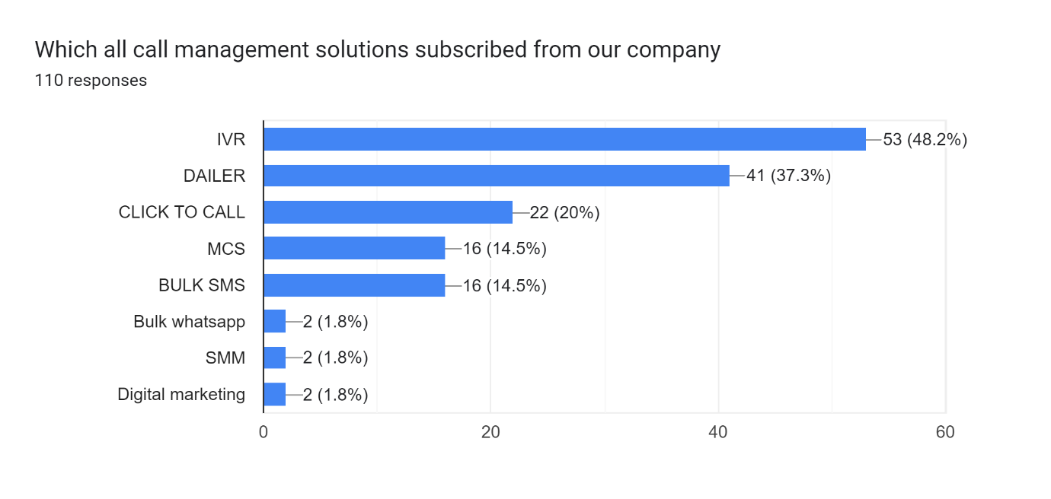

**Fig 4.2.2 showing which all call management solutions are subscribed**

**Inference**

Majority of the respondents (48.2 %) are using IVR followed by, (37.3 %) are DAILER, (20%) are using CLICK TO CALL and (14.5%) are using MCS and BULK SMS

**Table 4.2.3 showing the customer’s easiness was it to navigate through our mobile application?**

|  |  |  |
| --- | --- | --- |
| Response | Frequency | Percentage |
| Extremely satisfied | 27 | 24.5 |
| Very satisfied | 62 | 56.4 |
| Somewhat satisfied | 15 | 13.6 |
| Slightly satisfied | 5 | 4.5 |
| Not satisfied | 1 | 0.9 |
| Total | 110 | 100 |

**Fig 4.2.3 showing the customer’s easiness was it to navigate through our mobile application**

**Inference**

Majority of the respondents (56.4 %) are Very Satisfied to the easiness it to navigate through mobile application followed by, (24.5 %) are Extremely Satisfied, (13.6%) are Somewhat satisfied and (4.5%) are Slightly satisfied

**Table 4.2.4 showing how well the product meet customer’s expectations**

|  |  |  |
| --- | --- | --- |
| **Response** | **Frequency** | **Percentage** |
| Extremely satisfied | 26 | 23.6 |
| Very satisfied | 64 | 58.2 |
| Somewhat satisfied | 13 | 11.8 |
| Slightly satisfied | 7 | 6.4 |
| Not satisfied | 0 | 0 |
| Total | 110 | 100 |

**Fig 4.2.4 showing how well the product meet customer’s expectations**

**Inference**

Majority of the respondents (58.2 %) are Very Satisfied with the expectation of the product followed by, (23.3 %) are Extremely Satisfied, (11.8%) are Somewhat satisfied and (6.4%) are Slightly satisfied with the expectation of the product

**Table 4.2.5 showing the Rating of satisfaction with team in resolving customer’s issue**

|  |  |  |
| --- | --- | --- |
| **Response** | **Frequency** | **Percentage** |
| Excellent | 33 | 30 |
| Very good | 53 | 48.2 |
| Good | 23 | 20.9 |
| Average | 1 | 0.9 |
| Below average | 0 | 0 |
| Total | 110 | 100 |

**Fig 4.2.5 showing the Rating of satisfaction with team in resolving customer’s issue**

**Inference**

Majority of the respondents (48.2 %) are rated as the Very Good to the satisfaction with team in resolving the issue followed by, (30 %) are rated as Excellent, (20.9%) are rated as good in resolving the issue

**Table 4.2.6 showing rating of customers to the product knowledge of our sales and customer care representative**

|  |  |  |
| --- | --- | --- |
| **Response** | **Frequency** | **Percentage** |
| Excellent | 35 | 31.8 |
| Very good | 42 | 38.2 |
| Good | 26 | 23.6 |
| Average | 6 | 5.5 |
| Below average | 1 | 0.9 |
| Total | 110 | 100 |

**Fig 4.2.6 showing rating of customers to the product knowledge of our sales**

**and customer care representative**

**Inference**

Majority of the respondents (38.2 %) are rated as the Very Good to the sales and customer care representative followed by, (31.8 %) are rated as Excellent, (23.6%) are rated as good

**Table 4.2.7 showing how customers are satisfied with the delivery of our product**

|  |  |  |
| --- | --- | --- |
| **Response** | **Frequency** | **Percentage** |
| Extremely satisfied | 26 | 23.6 |
| Very satisfied | 67 | 60.9 |
| Somewhat satisfied | 11 | 10 |
| Slightly satisfied | 5 | 4.5 |
| Not satisfied | 1 | 0.9 |
| Total | 110 | 100 |

**Fig 4.2.7 showing how customers are satisfied with the delivery of our product**

**Inference**

Majority of the respondents (60.9 %) are Very Satisfied with the delivery of the product followed by, (23.6 %) are Extremely Satisfied, (10 %) are Somewhat satisfied with the delivery of the product

**Table 4.2.8 showing how satisfied customer with the prompt service of customer care executive**

|  |  |  |
| --- | --- | --- |
| **Response** | **Frequency** | **Percentage** |
| Extremely satisfied | 28 | 25.5 |
| Very satisfied | 57 | 51.8 |
| Somewhat satisfied | 15 | 13.6 |
| Slightly satisfied | 8 | 7.3 |
| Not satisfied | 2 | 1.8 |
| Total | 110 | 100 |

**Fig 4.2.8 showing how satisfied customer with the prompt service of customer care executive**

**Inference**

Majority of the respondents (51.8 %) are Very Satisfied with theprompt service of customer care executive followed by, (25.5 %) are Extremely Satisfied, (13.6 %) are Somewhat satisfied with the prompt service customer care executive

**Table 4.2.9 showing how customers would rate the competence of customer care executives**

|  |  |  |
| --- | --- | --- |
| **Response** | **Frequency** | **Percentage** |
| Extremely satisfied | 29 | 26.4 |
| Very satisfied | 53 | 48.2 |
| Somewhat satisfied | 18 | 16.4 |
| Slightly satisfied | 10 | 9.1 |
| Not satisfied | 0 | 0 |
| Total | 110 | 100 |

**Fig 4.2.9 showing How customers would rated the competence of customer care executives**

**Inference**

Majority of the respondents (48.2 %) are Very Satisfied with the competence of customer care executive followed by, (26.4 %) are Extremely Satisfied, (16.4%) are Somewhat satisfied and (9.1%) are Slightly satisfied with the competence of customer care executives

**Table 4.2.10 showing Rating company’s products or services for following parameters**

**Features**

|  |  |  |
| --- | --- | --- |
| **Response** | **Frequency** | **Percentage** |
| Extremely satisfied | 29 | 26.4 |
| Very satisfied | 53 | 48.2 |
| Somewhat satisfied | 18 | 16.4 |
| Slightly satisfied | 10 | 9.1 |
| Not satisfied | 0 | 0 |
| Total | 110 | 100 |

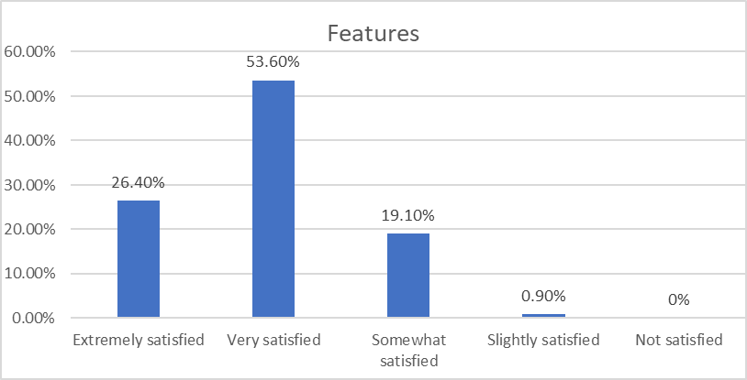

**Fig 4.2.10 showing Rating company’s products or services for following parameters**

**Inference**

Majority of the respondents (53.6 %) are Very Satisfied with the features product followed by, (26.4 %) are Extremely Satisfied, (19.1%) are Somewhat satisfied and (9.1%) are Slightly satisfied with the features

**Table 4.2.11 showing how customer rated about pricing of product**

**Pricing**

|  |  |  |
| --- | --- | --- |
| **Response** | **Frequency** | **Percentage** |
| Extremely satisfied | 49 | 44.55 |
| Very satisfied | 46 | 41.82 |
| Somewhat satisfied | 12 | 10.9 |
| Slightly satisfied | 3 | 2.73 |
| Not satisfied | 0 | 0 |
| Total | 110 | 100 |

**Fig 4.2.11 showing how customer rated about pricing of product**

**Inference**

Majority of the respondents (44.5 %) are Extremely Satisfied with the pricing of the product followed by, (41.82 %) are very Satisfied, (10.9%) are Somewhat satisfied and (2.73%) are Slightly satisfied with the pricing

**Table 4.2.12 showing how customer rated about customer support of the company**

**Customer support**

|  |  |  |
| --- | --- | --- |
| **Response** | **Frequency** | **Percentage** |
| Extremely satisfied | 45 | 44.5 |
| Very satisfied | 43 | 39 |
| Somewhat satisfied | 19 | 17.27 |
| Slightly satisfied | 5 | 4.54 |
| Not satisfied | 1 | 0.9 |
| Total | 110 | 100 |

**Fig 4.2.12 showing how customer rated about customer support of the company**

**Inference**

Majority of the respondents (44.5 %) are Extremely Satisfied with the customer support of the company followed by, (39 %) are very Satisfied, (17.27%) are Somewhat satisfied and (4.5 %) are Slightly satisfied with the customer support

**Table 4.2.13 showing rating of transparancy billing methods**

|  |  |  |
| --- | --- | --- |
| **Response** | **Frequency** | **Percentage** |
| Extremely satisfied | 21 | 19.1 |
| Very satisfied | 64 | 58.2 |
| Somewhat satisfied | 20 | 18.2 |
| Slightly satisfied | 5 | 4.5 |
| Not satisfied | 0 | 0 |
| Total | 110 | 100 |

**Fig 4.2.13 showing rating of transparancy billing methods**

**Inference**

Majority of the respondents (58.8 %) are Very Satisfied with the transparancy of billing of the company followed by, (19.1%) are Extremely Satisfied, (18.2%) are Somewhat satisfied and (4.5 %) are Slightly satisfied with the transparancy of billing

**Table 4.2.14 showing rating of the overall value of our product**

|  |  |  |
| --- | --- | --- |
| **Response** | **Frequency** | **Percentage** |
| Very high value | 16 | 14.5 |
| High value | 69 | 62.7 |
| Neutral | 20 | 18.2 |
| Low value | 4 | 3.6 |
| Very low value | 1 | 0.9 |
| Total | 110 | 100 |

**Fig 4.2.14 showing rating of the overall value of our product**

**Inference**

Majority of the respondents (62.7.8 %) are rated as the high value with the product followed by, (14.5%) are very high value, (18.2%) are neutral with the overall value of the product

|  |  |  |
| --- | --- | --- |
| **Response** | **Frequency** | **Percentage** |
| Extremely satisfied | 24 | 21.8 |
| Very satisfied | 64 | 58.2 |
| Somewhat satisfied | 17 | 15.5 |
| Slightly satisfied | 5 | 4.5 |
| Not satisfied | 0 | 0 |
| Total | 110 | 100 |

**Table 4.2.15 showing how customer would rate products compared with competitors**

**Fig 4.2.15 showing how customer would rate products compared with competitors**

**Inference**

Majority of the respondents (58.82 %) are Very Satisfied with the product compared with competitor followed by, (21.8%) are Extremely Satisfied, (15.5%) are Somewhat satisfied and (4.5 %) are Slightly satisfied with the product compared with competitor

**Table 4.2.16 showing recommendation customer to your friends or relatives to buy products.**

|  |  |  |
| --- | --- | --- |
| **Response** | **Frequency** | **Percentage** |
| Very likely | 29 | 26.4 |
| Likely | 57 | 51.8 |
| Neutral | 20 | 18.2 |
| Unlikely | 2 | 1.8 |
| Very unlikely | 2 | 1.8 |
| Total | 110 | 100 |

**Fig 4.2.16 showing recommendation customer to your friends or relatives to buy products.**

**Inference**

Majority of the respondents (51.8 %) are likely to recommend the product followed by, (26.4%) are Very likely, (18.2%) are neutral with recommendation of the product to friends and family

**Table 4.2.17 showing customer to interested in checking out other products or services**

|  |  |  |
| --- | --- | --- |
| Response | Frequency | Percentage |
| Yes | 65 | 59.1 |
| No | 45 | 40.9 |
| Total | 110 | 100 |

**Fig 4.2.17 showing customer to interested in checking out other products or services**

**Inference**

Majority of the respondents (59.1%) are interested in checking new products or services and (40.9%) are not interested in checking new product.

**Table 4.2.18 showing which all the parameters company would change**

|  |  |  |
| --- | --- | --- |
| Response | Frequency | Percentage |
| Product updation | 52 | 47.3 |
| Customer service | 35 | 31.8 |
| Pricing | 43 | 39.1 |
| Others | 1 | 0.9 |
| Total | 110 | 100 |

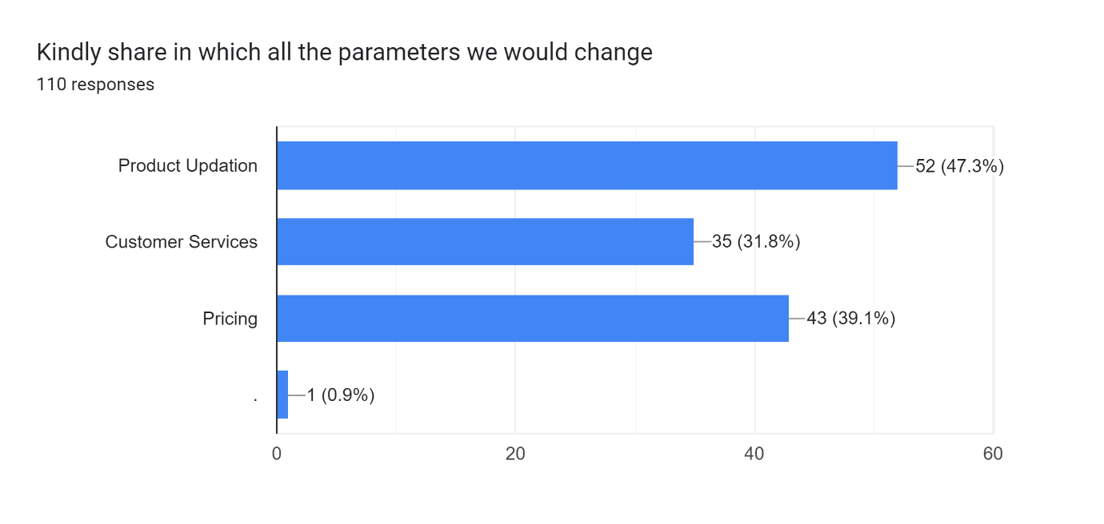

**Fig 4.2.18 showing which all the parameters company would change**

**Inference**

Majority of the respondents (47.3.1%) are noted as product updation followed by (39.1 %) are noted as pricing and (31.8 % ) as customer services

**5.1 Findings**

The following details can be inferred after analysis with a sample size of 110 which included customers, by questionnaire method to understand the customer satisfaction towards Modern food products.

* Majority of respondents are (49.1%) are using the product below 6 months
* Majority of respondents are using product IVR
* Majority of respondents (80.9%) are satisfied with the easiness of mobile application
* Majority of the customers (81.8 %) are satisfied with the statement product meet expectations
* Majority of the respondents (78.9%) right satisfaction with our team in resolving your issue as very good
* Majority of the respondents (70 %) are satisfied product knowledge of sales and customer care representative
* Majority of the respondents (84.5 % ) are satisfied with the delivery of product.
* Majority of respondents (74.6%) are satisfied with the competence of customer care executives
* Majority of respondents (77.3) are satisfied with prompt service customer care executives
* Majority of the respondents (83.5%) are satisfied with the customer support
* Majority of the respondents (86.37 %) are satisfied with the pricing of products or services
* Majority of the respondents (80 % ) are satisfied with the features of products or services
* Majority of the respondents (77.3 %) are satisfied with the billing methods
* Majority of the respondents 77.2 %) gives high value to the overall value of the product.
* Majority of the respondents (80 %) are satisfied with the products when compared to the competitor
* Majority the respondents (78.2.8 %) are likely to recommend products to the friends or relatives.
* Majority of the respondents (63.3 ) are interested in checking out other products or services
* Majority of the respondents (47.3 %) selected product updation as the important parameter to change

**5.2 Suggestions**

* As from this study we can see that most of respondents are using IVR so bonvoice needed to more focus on selling other products.
* Company needed to focus on the product knowledge of sales and customer support team. Company needed to educate them with product.
* Company must pitch more products to customers because majority of customers are interested in checking new products
* Company must research on product updation. Because majority of the respondents are noted as they need product updation.

**5.3 Conclusion**

The project entitled ‘A study on service quality and customer satisfaction with reference to Bonvoice Solutions Pvt Ltd’ is the research topic and 110 customers were taken as sample. The study was conducted for analysing the service quality and customer satisfaction in Bonvoice Solutions Pvt Ltd.

By making this research it proved that most of the respondents are very satisfied with service quality and satisfaction level. The most of respondents are interested in checking new product and services. The most respondents are noted as they more updation in their products and also company need to focus more on other products too.